Hubble Fellowship News
Ron Allen, rjallen@stsci.edu
The Hubble Fellowship Program provides postdoctoral fellowships to candidates of exceptional research promise. The program includes the scientific goals addressed by any of the missions in NASA’s Cosmic Origins Program. These missions presently include: the Hubble Space Telescope, Spitzer Space Telescope, Stratospheric Observatory for Infrared Astronomy, the Herschel Space Observatory, and the James Webb Space Telescope. This program is funded by NASA and is open to applicants of any nationality. The fellowships are tenable at U.S. host institutions of the fellows’ choice, subject to a maximum of one new fellow per host institution per year. The duration of the fellowship is up to three years. More details are available at http://www.stsci.edu/institute/org/spd/hubble-fellowship.

Selection of the 2011 Hubble Fellows

The 2011 Hubble Fellow Selection Committee met at the Institute on January 20–21, 2011, to consider the 269 applications that were received by the deadline of November 4, 2010. The selection criteria remained the same as in the past. The number of Hubble Fellowships to be awarded for 2011 is 17, the same as the previous year. Prof. Rene Walterbos (New Mexico State University) chaired the 15-member committee. Offers were made, and by mid-February the list of 2011 Hubble Fellows was complete; see Table 1. They will take up their new fellowships in the fall of 2011.

Table 1. 2011 Hubble Fellows

2011 HUBBLE FELLOW | Ph.D. INSTITUTION | HOST INSTITUTION
1. Gurtina Besla | Harvard – 2011 | Columbia
2. Jo Bovy | NYU – 2011 | IAS
3. Sean Couch | UT-Austin – 2010 | Chicago
4. Nathalie Degenaar | Amsterdam NL – 2010 | Michigan
5. Steven Finkelstein | Arizona – 2008 | UT-Austin
6. Evghenii Gaburov | Amsterdam NL – 2008 | Northwestern
7. Markus Janson | MPI-DE – 2008 | Princeton
8. Linhua Jiang | Arizona – 2008 | ASU
9. Jeyhan Kartaltepe | Hawaii – 2009 | NOAO-Tucson
10. Mansi Kasliwal | Caltech – 2011 | OCIW
11. Christiaan Ormel | Groningen NL – 2008 | UCB
12. Joshua Peek | UCB – 2008 | Columbia
13. Daniel Perley | UCB – 2011 | Caltech
14. Ralph Schoenrich | MPI-DE – 2011 | OSU
15. Roman Shcherbakov | Harvard – 2011 | UMD
16. Daniel Stark | Caltech – 2008 | Arizona
17. John Tobin | Michigan – 2011 | NRAO

2011 Hubble Fellows Symposium(March 8–10, 2011)
This year, we begin the third decade of the Hubble Fellowship Program, now expanded to include all present and future missions in NASA’s Cosmic Origins theme. For virtually all of its existence, the program has been and remains one of the leading fellowship programs in the field of astronomy and astrophysics. It has supported more than 220 of the most prominent and active scientists in this field at a crucial phase in their careers. The Hubble Fellowship Program continues to be one of the highlights of NASA’s pursuit of excellence in space science. Each year, the current Hubble Fellows—about 45 in 2011—convene for a three-day symposium to present the results of their recent research and to meet face-to-face with other Hubble Fellows and the scientific and administrative staff who manage the program.
The NASA Cosmic Origins theme (http://science.nasa.gov/about-us/smd-programs/cosmic-origins/) includes the Spitzer Observatory (http://www.spitzer.caltech.edu/). The Spitzer Fellowship Program (http://irsa.ipac.caltech.edu/data/SPITZER/docs/spitzermission/communityprograms/spitzerfellows/) was incorporated in the Cosmic Origins Hubble Program two years ago. Therefore, 2011 is the final year of tenure for the remaining Spitzer Fellows. To mark this occasion, and to commemorate the success of the Spitzer Fellows Program, the 2011 Hubble Fellows Symposium included participation by the current Spitzer Fellows, and was held in Pasadena under the joint auspices of the Spitzer Science Center (http://ssc.spitzer.caltech.edu/mtgs/fellows2011/) and the Space Telescope Science Institute. The participants posed for a group photograph, shown in the figure below. The program and recorded video of the symposium are available at https://webcast.stsci.edu/webcast/archive.xhtml.
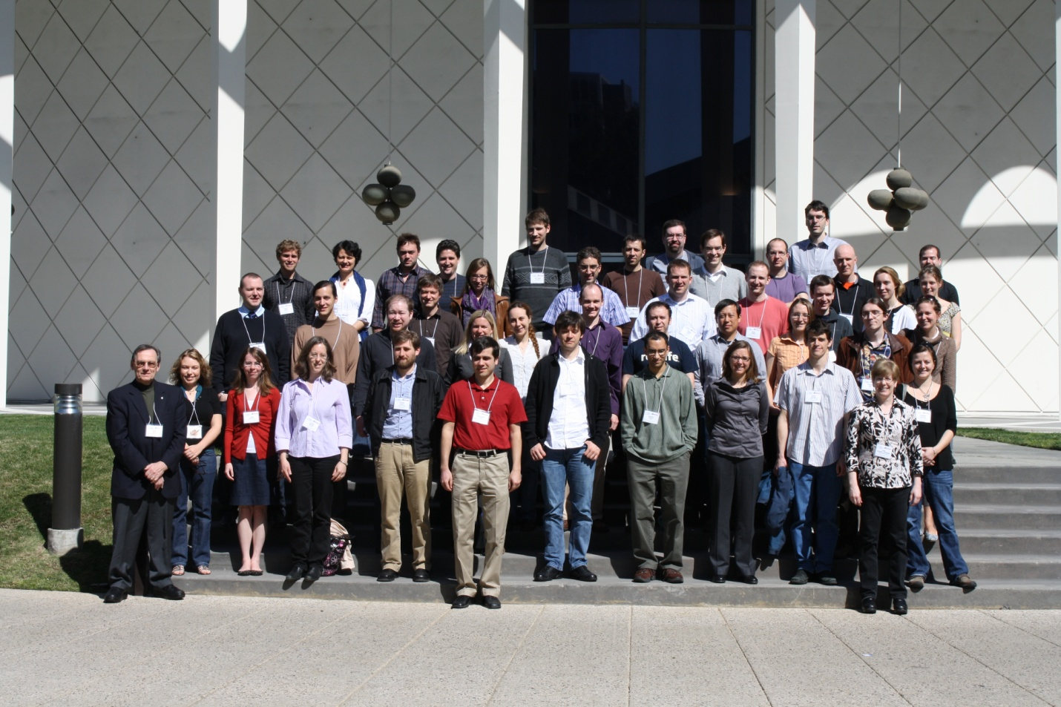

Photo Caption: Hubble and Spitzer Fellows at Caltech during the 21st Hubble Fellows Symposium

