USE CASE #1 for hst1pass

This is a simple demonstration of perturbation PSFs and subtracted images.

00.ORIG
This directory contains one file ibc301qrq_flt.fits, which is a pretty typical exposure at the center of Omega Cen. It has an exposure time of 40s and was taken through F606W in 2010.

01.NOPERT
In this directory, I run hst1pass with the following command:
./hst1pass.ee \
HMIN=5 \
FMIN=1000 \
PSF=STDPSF_WFC3UV_F606W.fits \
OUT=xympq \
SHOW_SUB+ \
../00.ORIG/ibc301qrq_flt.fits
It generates two files:
- ibc301qrq_flt.xympq: the list of found stars
- ibc301qrq_sub.fits: the subtracted images (4096x4096 abutted system)

You can look at the _sub.fits file and blink it with the file in the ORIG directory to see which stars were found and removed.

02. PERT1
In this directory, I run hst1pass with the following command (same as above with with PERT=1 on another line):
./hst1pass.ee \
HMIN=5 \
FMIN=1000 \
PSF=STDPSF_WFC3UV_F606W.fits \
PERT=1 \
OUT=xympq \
SHOW_SUB+ \
../00.ORIG/ibc301qrq_flt.fits

This routine outputs four files, the two above (though they contain different data) and an additional file called LOG.psfperts.fits.
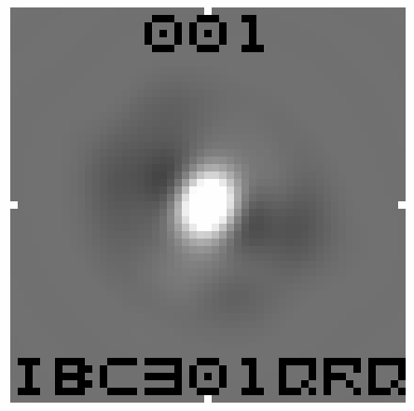
It looks like this with a grayscale where dark is positive. It’s a representation of the perturbation, the difference between the PSF of the stars in the image and the library PSF. The central intensity is -0.016. The library PSF’s central intensity is about 0.16, so this means the flux is down by about 10% in the center of the PSF. There is an increase of flux outside of the core with much of it coming at 10 o’clock and 4 o’clock. The 001 at the top just indicates that this is the perturbation for the 1st image. The hst1pass routine can handle 100 or so at a time. The rootname of the image is given at the bottom, for reference.
The routine also outputs ibc301qrq_psf.fits, a STDPSF-format file that contains a that combines the library F606W PSF with the perturbation added.
The “xympq” file and the “_sub.fits” file reflect the improved PSF results.
In the figure below, we compare the original flt image on the left, the STDPSF-subtracted _sub image in the middle, and the STDPSF+PERT1-subtracted image on the right.
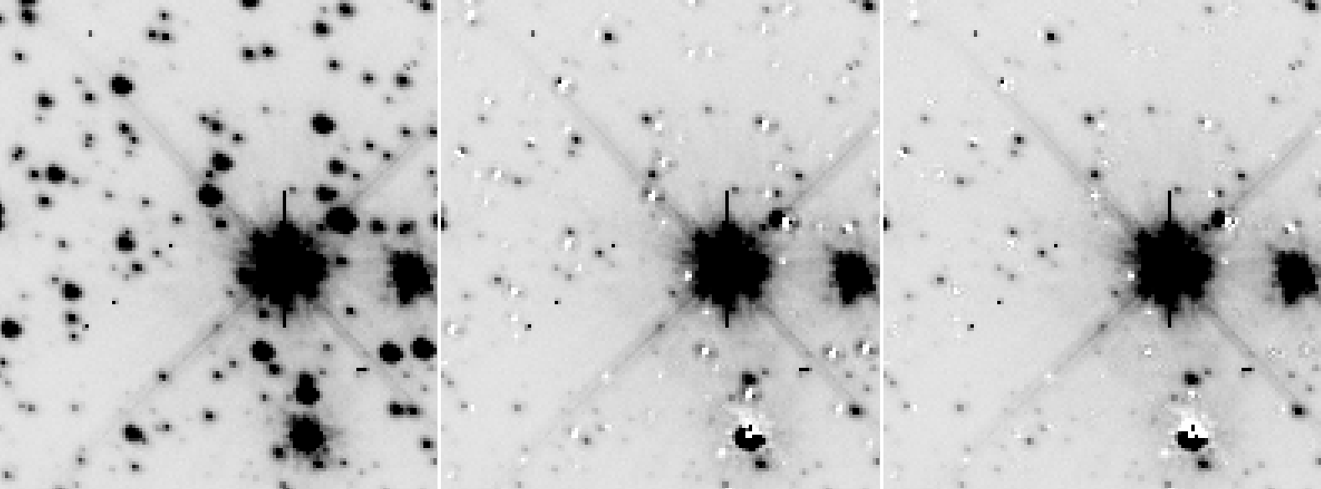

The PSF in the original image is clearly not perfectly fit by the library PSF. The perturbation makes a significant improvement in the subtraction of stars.

If we plot up the q parameter for the two runs (PERT0 and PERT1), we see that the bright stars were indeed fit better by the perturbed model. The typical q value is 0.02 for the PERT1 reduction, but 0.06 for the PERT0 reduction.
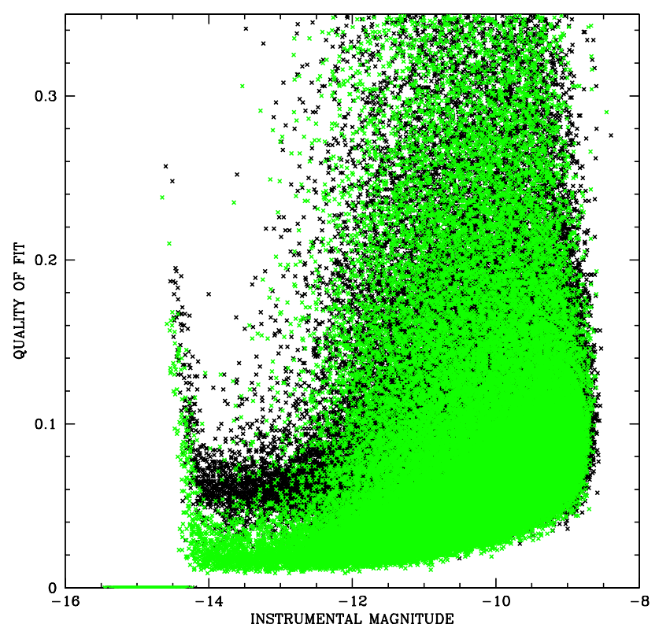
Note that the quality of fit gets much worse for the stars that are presumably just below saturation. This is likely an artifact of the fact that this image was generated by the pipeline long ago, before the saturation flags were carefully calibrated.

In general, the hst1pass routine trusts the saturation flags implicitly, but if for some reason they are found wanting, you can always plot q against p as below.

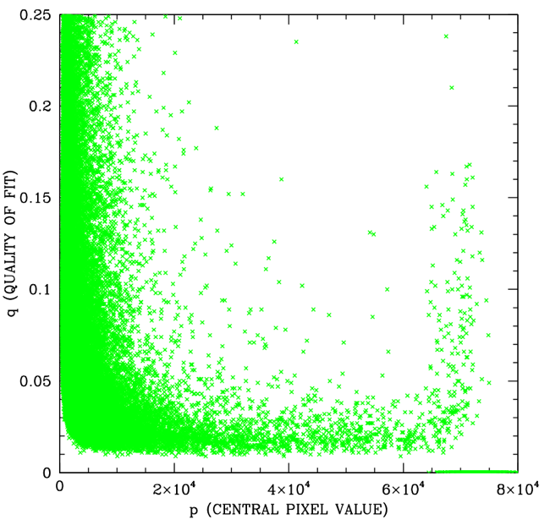
It’s clear that if we re-run hst1pass with an additional parameter HIFLAG=65000, then it will end up manually flagging all these stars as saturated and will measure them accordingly. Alternatively, one could re-process (or re-download) the images from mast and the problem should be fixed.

