
JWST TECHNICAL REPORT
Title: The JWST Calibration Field: Absolute Astrometry and Proper Motions with GAIA and a Second HST Epoch |  | Doc #:  Date:  Rev: - | JWST-STScI-007716, SM-12  28 Jan 2021
Authors: Jay Anderson  Mike Fall, and the Astrometry Working Group | Phone: 410-338-4982 | Release Date:

Abstract
When JWST’s calibration field in the LMC (Large Magellanic Field) was observed in 2006, it was thought that launch would be only seven years away in 2013. Launch is now scheduled for 2021, 15 years after the initial calibration-field observations. In order to keep the catalog current, we took a second epoch of HST observations and designed them to repeat the first epoch as closely as possible. In addition to more HST observations to fold in, the GAIA catalog of absolute positions and motions became available in 2017, allowing us to construct not only a locally flat reference frame, but one that was also calibrated in an absolute sense. We describe here the procedure we used to construct the latest reference-frame catalog. We provide detailed catalog with fluxes in V, J, H, K, L, and M, using actual observations where possible and color equations and isochrones to fill in missing fluxes. The catalog includes (1) the bright, isolated stars that can be measured well to pin down the distortion solution, (2) the fainter, more crowded stars, and (3) some artificial stars to fill out the luminosity function, so that JWST instrument teams can get a sense of how much crowding this more sensitive instrument should see.

Introduction
James Rhodes (2005) identified a general starfield in the LMC that had a “goldilocks”-type density for JWST calibration: it had plenty of stars to allow a very detailed distortion and L-flat-type photometric calibration, but it was not so crowded that the stars all interfered with each other. The starfield is also in JWST’s continuous viewing zone (the CVZ), which would allow JWST to visit this field immediately no matter when in the year it launched and throughout its lifetime thereafter. As such, this field will become a touchstone for the entire mission, allowing a great number of different calibrations. Diaz-Miller (2007) fine-tuned the field selection to a particular location that had low extinction and no extremely bright stars.
As with any galaxy, most stars are main-sequence stars, and the fact that the LMC stars are about 50 kpc away means that most of the stars in the field can be observed by JWST without saturating in the first few reads. This would not be true for typical globular cluster. The large distance of the LMC also means that most of the stars will be moving very slowly relative to one another (in a proper-motion sense), thus making this a better calibration field than the ones that HST uses in 47 Tuc and Omega Cen, where stars have relative motions of 0.5 to 1.0 mas/yr.
This field was observed through the F606W filter in the visible by the Wide Field Channel of HST’s Advanced Camera for Surveys (ACS/WFC) in 2006 with Program PID-10753 (PI-Diaz-Miller). Since it was well known even then that the ACS camera had skew terms that vary with time, observations were taken at two orthogonal orientations in an effort to ensure that the off-axis linear terms could be solved for and a proper rectilinear catalog could be produced. The majority of the exposures were taken with an exposure time of 350s, which is particularly efficient for ACS/WFC and also nicely matches the depth achieved with a few 10-second reads with JWST.
Anderson & Diaz (2011) created a catalog of about 180,000 bright, isolated stars in the field. In the time since the HST observations, the field has also been observed by HST’s WFC3 camera in both the visible and the IR, as well as with HAWK-I on the VLT. These observations have allowed explicit infrared color information for many of the brighter stars. The HAWK-I survey allowed a wider field to be surveyed (see Anderson 2008, Libralato et al 2014 and Sahlmann 2019). More recently, the all-sky GAIA catalog has been produced (GAIA Collaboration, 2016 and 2018), which enables an exquisite absolute astrometric calibration.
The 2006 observations were taken with a 2013 launch date in mind. As the launch date has slipped, the internal motions of the LMC stars have become more and more significant. If a typical LMC star is moving at 50 km/s relative to the bulk motion of its neighbors, then at the distance of 50 kpc, its relative proper motion will be 0.4 mas/yr. After 10 years, it will have moved 4 mas — more than a tenth of a NIRCam pixel! This makes the calibration catalog a very “fuzzy” handle to use to calibrate the distortion. For this reason, the Astrometry Working Group (AWG) sought additional observations at a second epoch (which was taken in 2017 under PID-14911, PI-Fall), so that the individual internal motions could be measured, thus making the catalog good for many years to come. This report summarizes these supplemental observations and the catalog that has been generated from the entire two-epoch dataset.
The advent of GAIA on the astrometry scene has increased both calibration possibilities and calibration expectations. At the time of the first epoch in 2006, the absolute proper motion of the LMC had barely just been measured (Kallivayalil 2006), and it was still controversial. The bulk motion of the LMC was not a significant concern, though, since the focus of the calibration field was simply to have a locally flat frame that could calibrate the distortions within an instrument.
Since GAIA has produced a catalog with precise absolute positions and motions across the sky, astronomers now expect more from all calibration fields. They would like to be able to use this field to do absolute as well as relative calibrations. As such, a large focus of this document will be to produce not only a catalog that has accurate relative positions and motions for the stars, but one that has accurate absolute positions and motions. The limited brightness overlap between HST and GAIA makes this task complicated, but not impossible.
This document is organized as follows. In §3, we describe the ACS observations at the two epochs, then in §4 we describe how we extracted a list of isolated, good S/N sources from each exposure and combined them into a common HST-based star list. In §5, we present the GAIA catalog and how it overlaps with stars that HST can measure. We then present a roadmap for the calibration plan. In §6 we construct the reference frame using GAIA and determine the LMC stars’ bulk motion in this frame by combining HST membership with absolute GAIA proper motions. In §7, we bootstrap the short-exposure lists, then the deep-exposure lists into GAIA-astrometrized reference frames for each epoch. In §8, we determine HST-based proper motions, and in §9 describe the final high-precision catalog. Finally, §10 provides a list of additional products available, including observed and estimated color information and additional stars to provide some context for the crowding of the bright, isolated stars.

The HST Observations
The observations were taken with HST’s ACS/WFC through the F606W filter in 2006, and the whole set of observations was repeated again in 2017 with negligible changes. Each epoch consisted of seven visits: five visits at the first orientation and two visits three months later with a 90° field rotation. Each visit consisted of a ~25 s short exposure followed by five ~375 s deep exposures. Dithering was significant and allowed the coverage to be expanded from a single ACS FOV of 2.3′×2.3′ to a total field of 5′×5′, which was designed to allow each of JWST’s instruments to fit within it. The first epoch was taken in April and July of 2006 and the second epoch in April and July of 2017. Figure 1 shows the field and depth of coverage at each location. Table 1 on the following page details the observations. Figure 2 shows the center locations and orientations of all the exposures.
In addition to the F606W ACS exposures taken explicitly for this catalog, there are also F606W WFC3/UVIS and F160W WFC3/IR exposures of the field. The latter can provide V−H color information for some of the catalog stars.
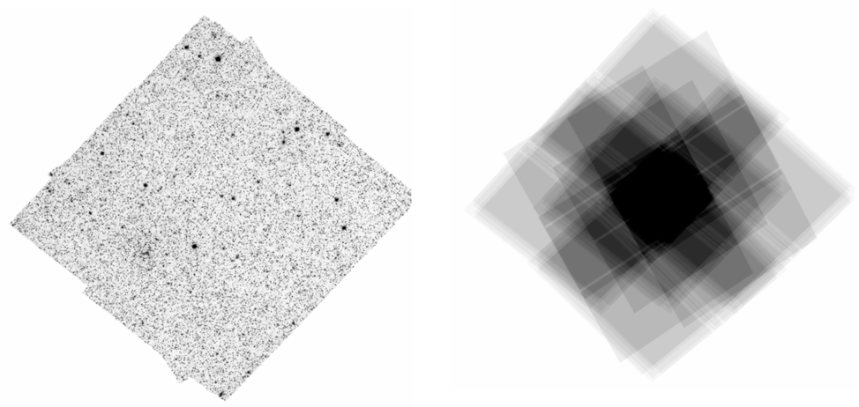
Figure 1: (Left) A stack of the first-epoch observations. The full frame here is 10,000 × 10,000 pixels (the ACS pixel scale is 50 mas/pixel). The ensquared frame is 500″ = 8.3′ on a side, while the actual covered region is about 5.3′ × 5.3′. (Right) The depth map showing how many deep exposures there are at each point in the field. The central region has a depth of 40 exposures, while the faintest levels have just single exposures. The images were dithered such that in a given pointing, stars would fall in the chip-gap only once.

Table 1: List of the 94 exposures taken with ACS/WFC for this reduction.
Date | Filter | Exposure time | PID
April 25-29, 2006 | F606W | 5×19s, 30×343s | 10753 (PI-Diaz-Miller)
July 8-11, 2006 | F606W | 2×32s, 10×423s | 10753 (PI-Diaz-Miller)
April 22-27, 2017 | F606W | 2×32s, 30×343s | 14911 (PI-Fall)
June 22, 2017 | F606W | 2×32s, 10×423s | 14911 (PI-Fall)

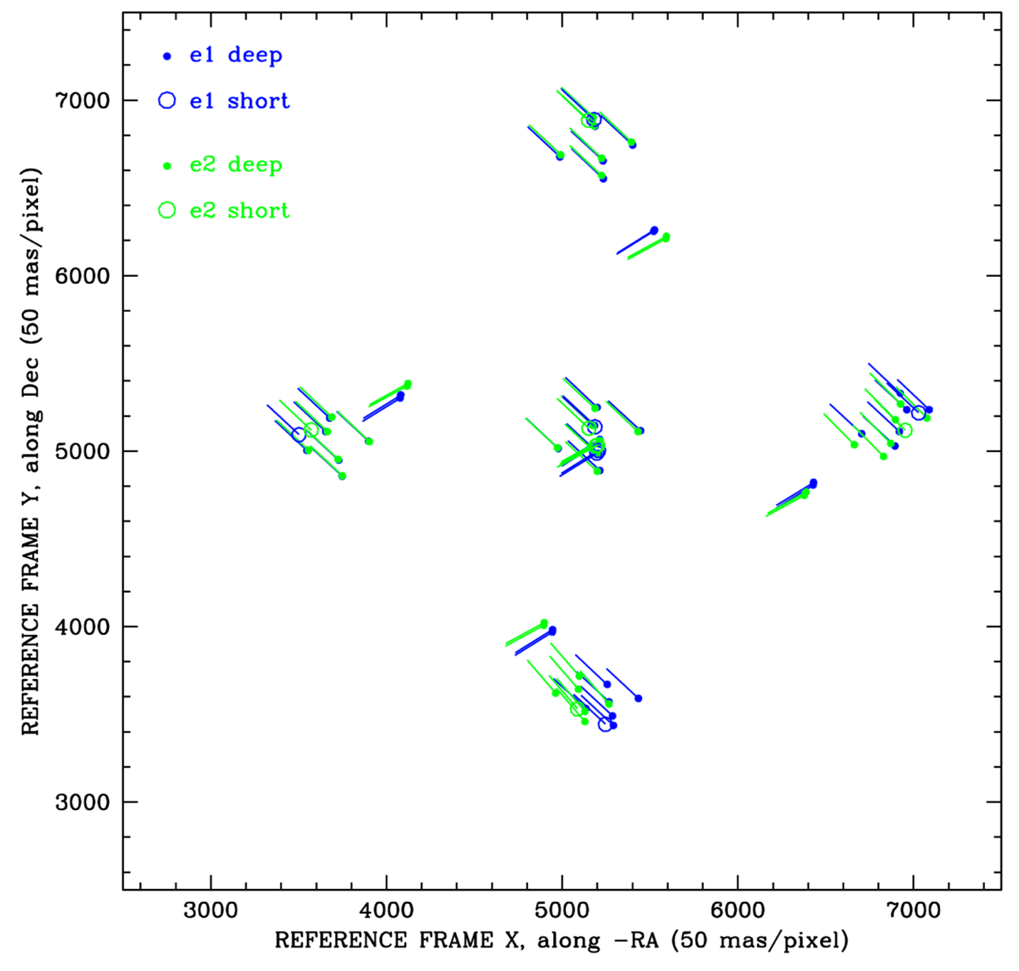
Figure 2: The centers and orientations of the 80 deep and 14 short exposures of the JWST calibration field. The lines show the orientation of the x-axis of each exposure.

Reducing the HST Observations
We downloaded all the _flc exposures from the archive. These ACS data products have been flat-fielded and corrected with version-2 of the pixel-based correction for blurring caused by CTE (charge-transfer efficiency; see Anderson & Bedin 2010 and Anderson & Ryon 2018).

4.1 Extracting a list of sources
We identified stars and measured their positions and fluxes in each exposure independently using the publicly available FORTRAN routine hst1pass (Anderson 2021). This produced 47 star lists for each epoch: 7 for the short exposures and 40 for the deep exposures. The routine searches through the exposures and identifies every local maximum (any pixel greater than its 8 adjacent and semi-adjacent neighbors) as a potential star. We further require each identified peak to be the brightest pixel within a radius of 5 and to have at least 500 electrons flux above a local sky in its brightest 2×2 pixels. (Note we are describing here the one-pass procedure; we will implement a multi-pass procedure later to find all possible stars; the current procedure is simply used to find the most astrometrically useful stars⎯namely, the bright and isolated ones.)
Once the list of isolated sources has been determined, the routine then uses an empirical library point-spread function (PSF) to determine an accurate flux and position for each potential source (Anderson & King 2006). It also identifies a single source at the center of every contiguous saturated block of pixels: the star’s flux is measured by adding up all the cascaded charge; the position is simply the pixel closest to the center of the saturated distribution. The saturated photometry is included just for reference, since its astrometric precision is very coarse.
The software routine reports five quantities for each source: x, y, m, p, and q. The quantities x and y refer to the local position in raw detector coordinates for each exposure. The quantity m refers to the instrumental magnitude; this corresponds to −2.5 times the log of the number of electrons within an aperture of 10 pixels. (Stars are actually measured by fitting the PSF to the star’s inner 5×5 pixels, but the “volume” of the PSF is normalized to unity within a radius of 10 pixels, or 0.5 arcsecond, such that the measured flux corresponds to the 10-pixel aperture). The quantity p refers to the value of the star’s brightest pixel, and q corresponds to the “quality of fit” (simply the absolute value of the PSF-fit residuals divided by the star’s total flux); q is close to zero for stars that most resemble the PSF and is set to 0.00 for saturated stars. In each deep exposure, there are about 70,000 unsaturated stars in the list and about 1,000 saturated stars.

4.2 Additional CTE correction
Even with the best pixel-based CTE correction, it is still often necessary to implement additional empirical corrections. Our focus here is astrometry, not photometry, so the astrometric corrections are the only ones we will consider. In general, when the electrons that make up the image of a star are shuffled down the detector, they encounter defects in the silicon lattice. These defects temporarily trap some electrons and prevent them from shuffling down with their original pixel.
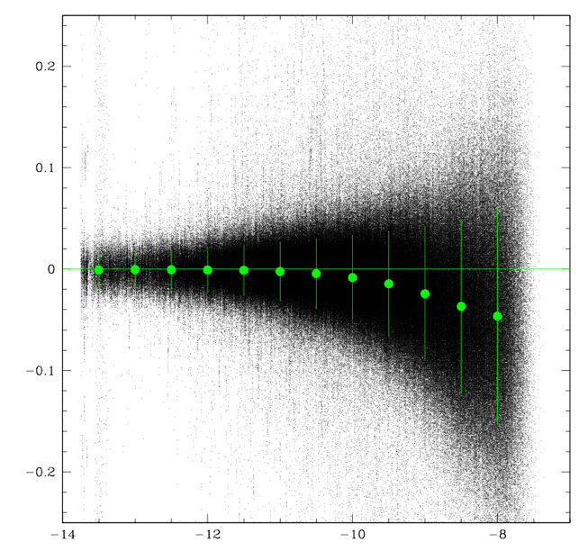
Figure 3: Supplemental CTE correction for the deep second-epoch exposures. Stars at instrumental magnitude −10 have about 10,000 total counts and a S/N of 100 and suffer vertical displacement of about 0.0075 pixel.
The traps eventually release the electrons into an upstream pixel. The impact on star images is that the pixels on the downstream side of the star image often lose electrons to the traps. By the time the upstream pixels of the star encounter the traps, the traps are full. The result is that the downstream pixels suffer more losses than the upstream pixels. In addition, the electrons trapped in the downstream pixels are released into upstream pixels. Both of these effects tend to shift the apparent position of the star upwards on the detector (i.e., away from the readout register).
The number of traps in the silicon that are accessible to an electron packet (a the contents of a pixel) depend on how many electrons there are in the packet. Bigger packets can see more traps, but the number of accessible traps does not grow linearly with the size of the packet. The result is that bright stars suffer less from CTE than faint stars in a percentage sense.
To examine CTE residuals, we cross-correlated the star lists from the 94 different exposures (80 deep and 14 short) and came up with a single master list. The easiest way to see CTE is to compare an image taken at one orientation with that taken at a 90°-orthogonal orientation. This way, the y-axis in one exposure corresponds to the x-axis in the comparison exposure. The y-coordinate in the first exposure should suffer from CTE, while the x-coordinate in the second should be largely free of it.
Within each epoch, we compared every exposure to every other exposure that was taken at an orthogonal orientation. These comparisons naturally made use of the distortion solution in Anderson (2007). We then plotted up the y-residual of the first exposure as a function of y and magnitude. Figure 3 above shows these residuals for the stars found close to the top of the bottom chip (y ~ 2000) of the second-epoch deep exposures. This is where the CTE impact is the largest.

4.3 Supplemental distortion correction
The library distortion solutions are not always perfect, and when the dataset allows, it is often good to make small changes to improve it. Figure 4 shows the residuals obtained by comparing every exposure against every other exposure within an epoch and averaging the residuals into 500×500-pixel bins. The benefit of making such comparisons within an epoch is that the stars should be in the same place, so that any displacement is indicative of either random measurement errors or distortion.
Using the above corrections, we now have new coordinates (u, v) to go along with the additional measurement parameters (m, p, q). These new coordinates have been corrected for both residual CTE effects and residual distortion. We thus carry along seven parameters for each stellar measurement: x, y, m, p, q, u, and v.

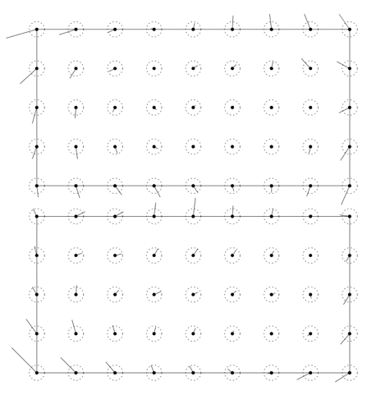 | 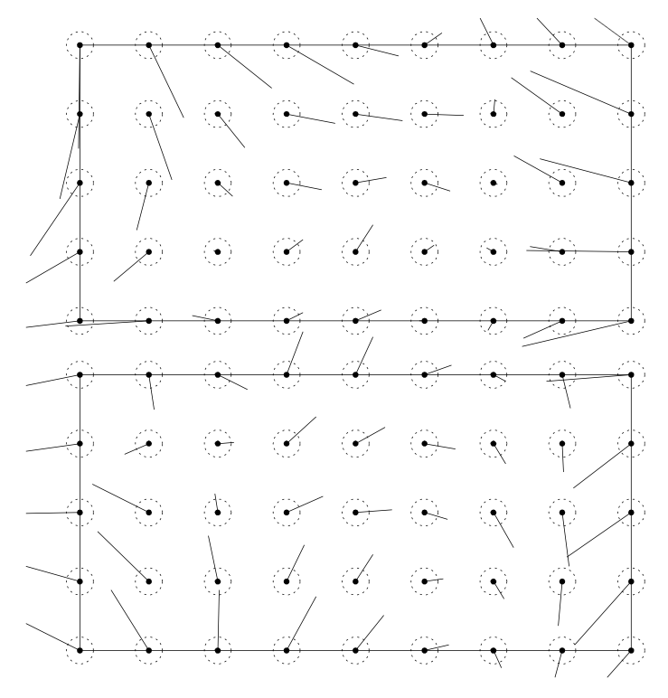
Figure 4: (Left) vector-point diagram showing the residual distortion for the 2006 data. The circles correspond to a residual of 0.01 pixel. (Right) same, but for the 2017 data. It is clear that the library distortion solution devised in 2006 needs improvement for post-SM4 (SM4, Servicing Mission 4, which happened in 2009).

The GAIA DR2 Catalog
In April 2018, the GAIA team released the second installment of positions, motions, and fluxes (DR2; Gaia Collaboration 2018). The GAIA catalog contains over a billion stars and clearly sets the standard for absolute astrometric accuracy and precision. (The DR3 catalog came out as this analysis was just completed; since we mostly used GAIA for the absolute calibration, which we got from many thousands of stars, the benefit of redoing everything with DR3 would be minimal.)
Unfortunately, the GAIA catalog is too sparse and too bright to meet all of JWST’s calibration needs. The faintest stars in the GAIA catalog are V ~ 20, and these stars have large measurement errors and are barely observable without saturation by JWST. It is clear that GAIA cannot take the place of the HST-observed field for JWST calibration, but we can make use of GAIA for the absolute astrometric and proper-motion calibration. In the next few sections, we compare the two catalogs to demonstrate where each can provide the best constraints, then we plot out a procedure that will lead to an accurate joint calibration.

5.1 Step#1: The good stars in the GAIA catalog
We downloaded the GAIA DR2 catalog in the vicinity of the calibration field and selected the stars that (1) were non-duplicate sources, (2) had astrometric excess noise of less than 5.0 and an error of less than 100.0 mas, and (3) had a parallax of more than −20 mas and a parallax error of less than 1 mas. This selection ended up removing just over 10% of the sources. Figure 5 shows the GAIA catalog that overlaps with the HST field. There are about 9000 GAIA stars that overlap the HST field.

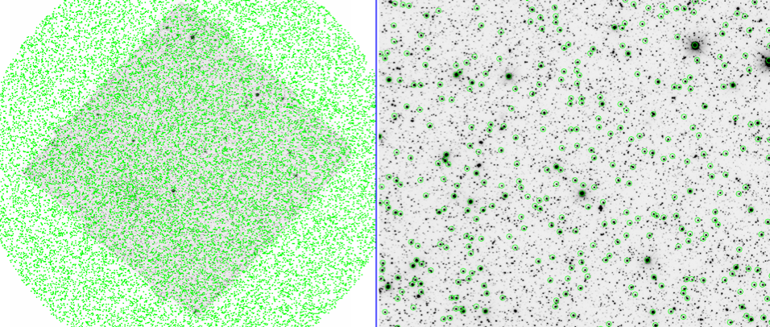
Figure 5: (Left) View of the entire JWST calibration field, with high-quality GAIA sources marked. (Right) Close up of the central square arcminute to provide a better sense of the density of GAIA sources.

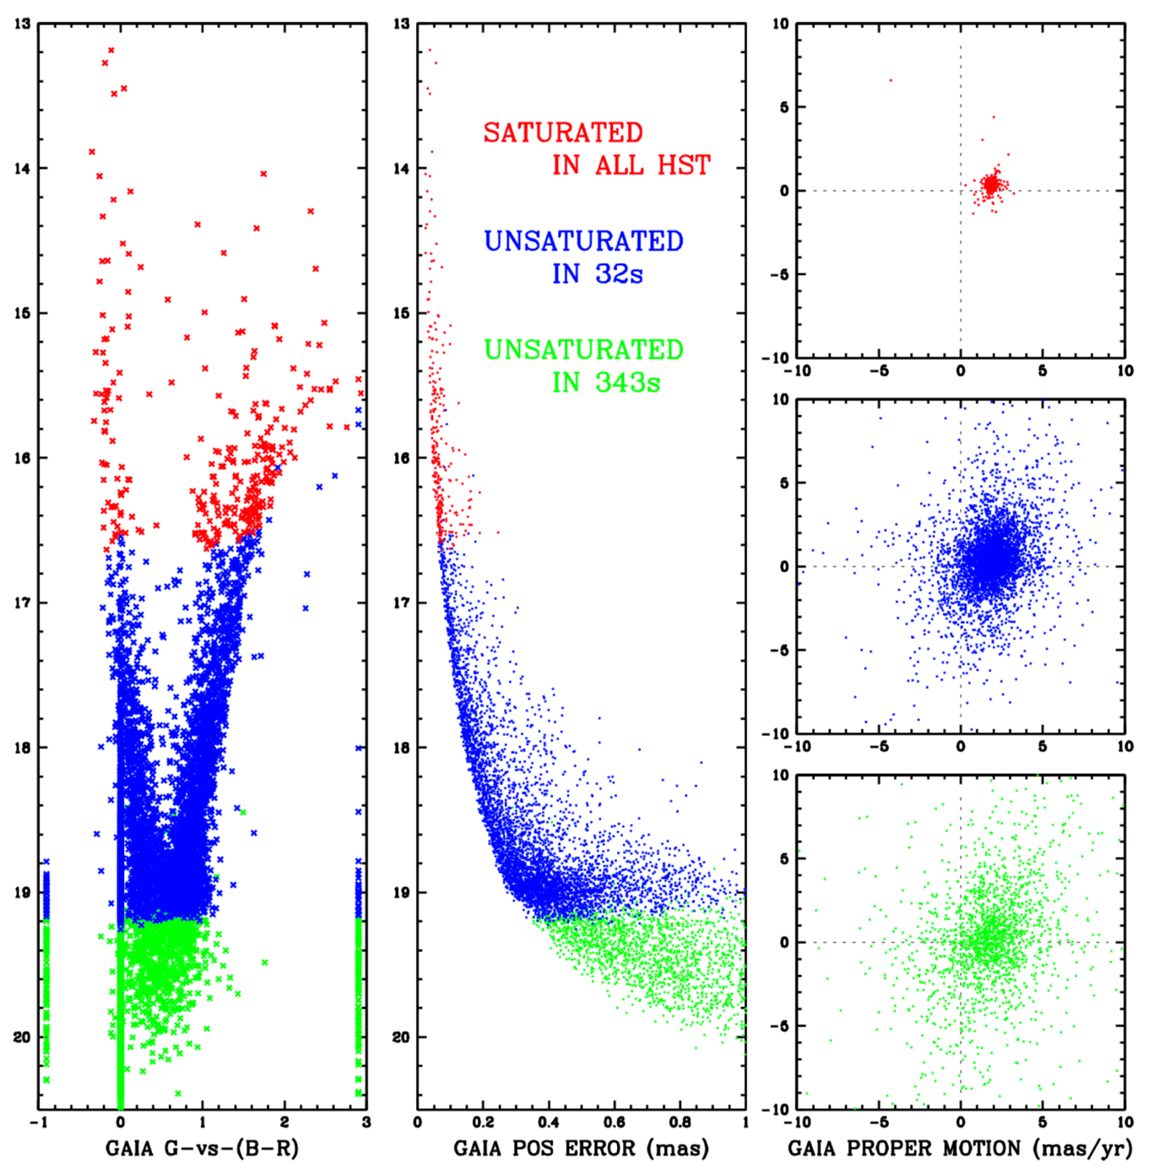
Figure 6: This shows the properties of the ~9000 GAIA stars that overlap the 5′ × 5′ HST field. Stars shown in red are saturated in all HST exposures, those in blue were saturated in the 80 deep exposures, but not in the 14 shallow exposures, and those in green are unsaturated in all HST exposures. (Left) The GAIA CMD. Stars at zero color were not measured in B or R, and stars at the left (right) were not measured in R (B), respectively. (Middle) The GAIA 2D errors in position, RA and Dec, in quadrature. (Right) The GAIA measured proper motions for the stars according to color code.
Figure 6 (above) shows the properties of the GAIA stars. On the left is the GAIA G versus B–V color-magnitude diagram. The middle panel shows the GAIA astrometric errors (for the reference epoch 2015.5), and the right panel shows the proper motions. The stars are color-coded according to how they were measurable by HST. The red stars were found to be saturated in all HST exposures: not much astrometry can be gleaned from them from HST. The blue stars were saturated in the deep exposures, but unsaturated in the short exposures. Finally, the green stars were found unsaturated even in the deepest exposures. These are the stars that both have the best HST measurements and will be the most useful for JWST calibration.
For comparison with the GAIA errors, the typical star measured in the deep HST exposures (the green stars) should have positional errors of ~1 mas in each exposure. With 20 exposures the typical positional error per star in an epoch should be 1 mas / $\sqrt{20}$ ~ 0.2 mas, and with a time baseline of 11 years the typical HST-measured PM error should be about 0.03 mas/yr.
The upper right panel for the brightest stars (coded in red) shows that the proper motion of most stars in the field is about −1.85 mas/yr in RA and about +0.30 mas/yr in Dec. This reflects the apparent systemic motion of the LMC about the Milky Way and the reflex motion of the Sun about the center of the Galaxy. There is a very small dispersion (about 0.2 mas/yr) in the GAIA motions about this value, indicating that the stars in the LMC have small relative motions.
A motion of 10 km/s at the 50-kpc distance of the LMC corresponds to about 0.05 mas/yr, so the tightness of the vector-point diagram for the red stars in the upper right is not surprising. The fainter blue and green stars exhibit a much larger scatter of motions about the average. This is likely due to the larger GAIA proper-motion errors for these stars, not real motions.

5.2 Matching GAIA with HST
When we initially attempted to match the GAIA catalog against the 2017.38 HST catalog from the short exposures, we first advanced the 2015.5 GAIA positions 1.86 years using the GAIA proper motions to the second HST epoch. The HST catalog (x,y) is not in an absolute frame, but rather a local distortion-corrected frame based on the central pointing. The GAIA catalog (U,V) was projected into a tangent plane centered on the field with the same pixel scale as the ACS images (50 mas/pixel). To compare these two catalogs, we found the linear transformation that minimized the residuals by least squares. Namely:
x'_{HST} = A ·(U_{GAIA} – U₀) + B·(V_{GAIA} – V₀) + X₀
y'_{HST} = C ·(U_{GAIA} – U₀) + D·(V_{GAIA} – V₀) + Y₀.
(It may appear that there are 8 free parameters here—A, B, C, D, X₀, Y₀, U₀, and V₀—but in actuality there are 6, since one of the positional zero-points is arbitrary. Note, also, that we compute a separate transformation for each of the four amplifiers in the ACS detector; this way, any first-order serial-CTE correction is also accounted for.)
We can then compute the residuals between the two frames by computing the difference between where HST found the star and where the GAIA catalog says HST should have found it: (x_{HST}-x'_{HST}) and (y_{HST}-y'_{HST}). Any offsets, bulk proper motions, or rotations will fall out of this comparison in the determination of the offsets and linear terms of the transformation. All we can evaluate here is the relative positions of the stars.
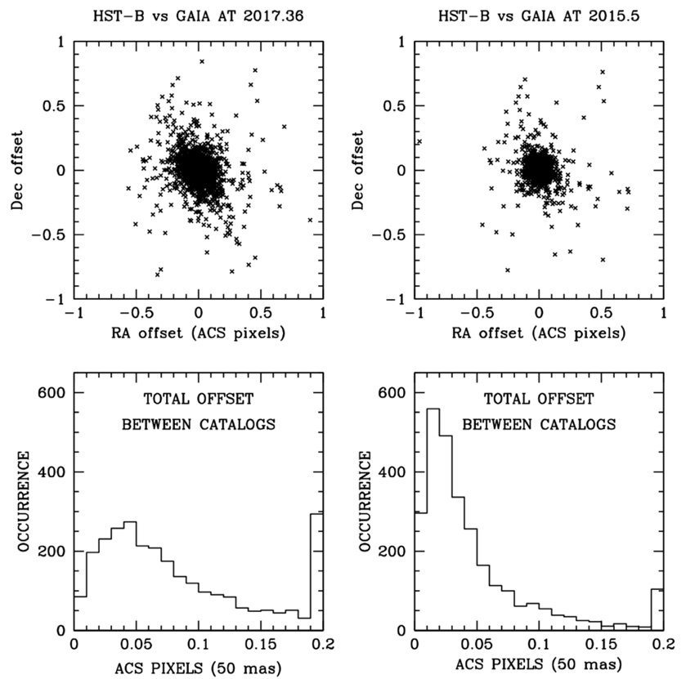
Figure 7: Position residuals between the short HST observations and two different versions of the GAIA catalog. One (on the left) had positions that were advanced to the epoch of the 2017 HST observations, and the other (on the right) at the original 2015.5 GAIA DR2 epoch.
When we computed the above residuals, we were surprised to find that the GAIA-HST positional agreement was worse when we used the GAIA positions evolved to 2017.38 than when we just used the 2015.5 GAIA positions without any accounting for the motion of the stars between the epochs. Figure 7 shows the comparison; the distribution on the right is clearly tighter.
At first glance, this was very puzzling. But upon careful reflection, we realized that it was because the relative internal-LMC proper motions for the GAIA stars were extremely poorly measured due to the distance to the LMC. It was better to assume that their relative motions were all zero than to make use of the actual measured value for the typical star.
This can be seen visually in the right panels of Figure 6. Although the LMC-star motions should be confined to a tiny ball (as seen by the red stars in the top right panel), the middle right panel shows that the GAIA motions for the blue stars (which were those measured in the short HST
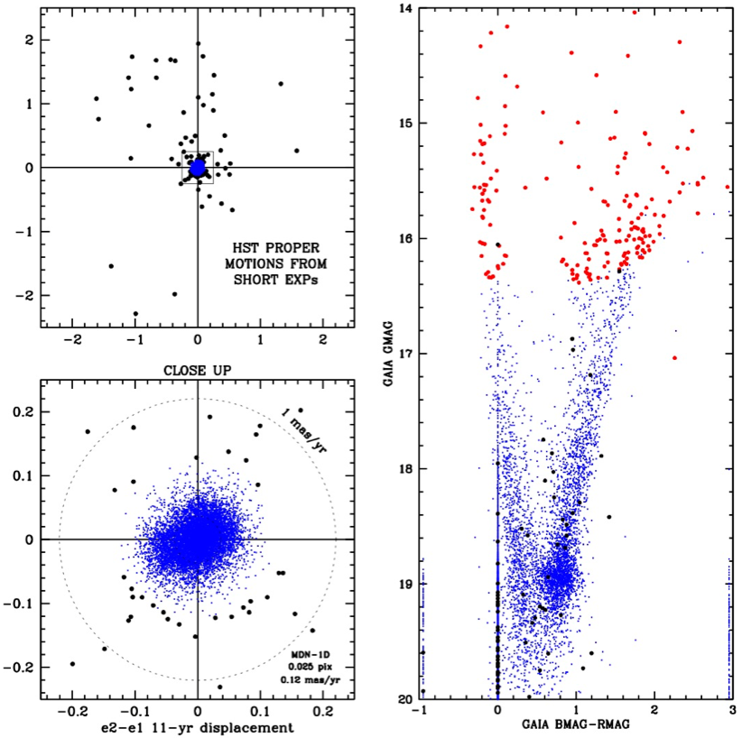
Figure 8: HST proper motions for the stars in the GAIA catalog. The HST frame is moving with the LMC, so the modal proper motion is zero, by construction. Upper left: Wide view, the fastest-moving stars are moving at about 10 mas/yr. Lower left: Close-up on the LMC stars. The typical RMS internal motion of LMS stars is about 0.12 mas/yr. Right: GAIA color-magnitude diagram. Red stars are saturated in HST. Black stars have non-LMC-type motions. (Note the displacements in x are in the –RA direction.)
images) are relatively faint in the GAIA catalog and have an appreciable measurement error. It is this scatter that is introducing error when we compare the relative positions of stars according to GAIA and according to HST.
Implicit in the comparison shown in Figure 7 is the fact that HST cannot measure the bulk motion of the LMC, without reference to extragalactic sources. The transformation from HST’s uncalibrated frame to GAIA’s absolute frame implicitly assumes zero bulk motion for the main population.
Figure 7 shows the HST-vs-GAIA displacements. The HST-measured displacements are shown in Figure 8. The upper left plot shows the wide view and the lower left plot shows the close up on the LMC stars. For the stars that are faint enough to be observed by HST, the HST displacements are much tighter all the way down than the GAIA displacements. Even though we need GAIA for the absolute proper-motion zero point, HST can clearly help us distinguish which stars are moving with the LMC, and it can give us accurate estimates of the LMC internal motions as well.

5.3 The challenges of calibrating HST with GAIA
This brings up several interesting challenges for the absolute calibration. When comparing GAIA and HST, we cannot compare the best-measured HST stars with the best-measured GAIA stars. The best measured GAIA stars are hopelessly saturated with HST, and the best measured HST stars are too faint for GAIA to measure well. So, we must proceed judiciously to merge the best elements from each catalog and use the best possible stars in common to do this.
On one hand, GAIA can tell us about the absolute reference frame (namely, the zeropoint and linear terms of the frame) and about the absolute proper motions for stars in the reference frame. But most of the stars of interest for JWST calibration are too faint to be found (and measured well) in the GAIA catalog.
On the other hand, HST gives us almost no information about the absolute reference frame or about absolute motions. But it does give us the best handle on the relative positions of stars and on their relative motions. This is particularly true for the fainter stars that JWST will be most dependent upon.
In the next section, we will construct the reference frame carefully using the framework provided by the GAIA catalog and the detailed positions and motions from HST. The process is not simple, since we need some information from HST to make best use of the GAIA catalog, but in the end, we will have a catalog with GAIA’s absolute accuracy and HST’s precision.
The flow chart in Figure 9 gives a roadmap for this procedure. We proceed from top to bottom from Step 1, where we construct the GAIA catalog of reliable stars, to Step 9, where we construct the final catalog. The horizontal bars tell us what brightness of stars we can use to go from one step to the next. We will flesh the details out in the following sections.

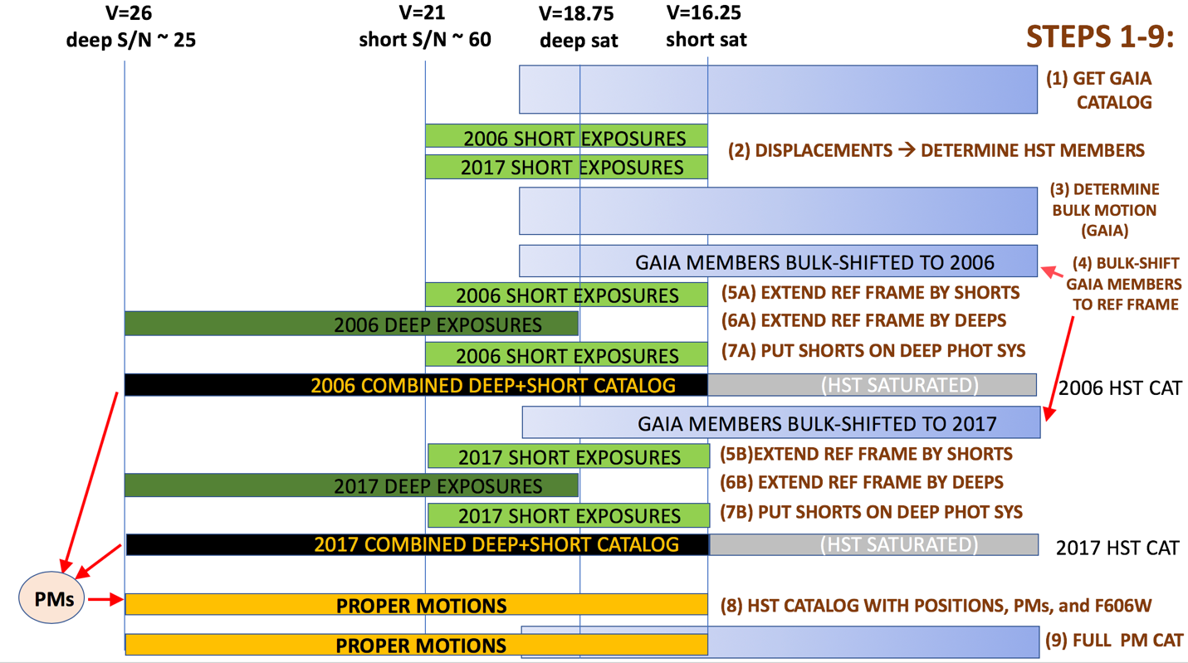
Figure 9: Flow chart showing (from top to bottom) the procedure we followed to construct a catalog with GAIA’s absolute accuracy and HST’s exquisite precision. The color-filled horizontal bars indicate what brightness range of stars was involved in each step.

Building the Reference Frame
Now that we have established the strengths and limitations of each catalog, it is time to do the absolute calibration. The flow chart in Figure 9 shows that we begin with the Gaia catalog (Step#1 in §4).
Unfortunately, as we discussed in the previous section, we do not have GAIA observations at either of the HST epochs, so we will have to construct some sort of intermediate reference frame. The absolute reference frame of GAIA is appropriate for epoch 2015.50. Our HST observations were taken at average epochs 2006.39 and 2017.38. Since the entire LMC field is moving, we cannot get a good absolute astrometric constraint without taking the bulk motion into account.
We showed in Figure 7 that if we project the motions forward using GAIA’s individual-star motions, the proper-motion errors severely degrade our knowledge of the positions in the desired epoch. So, even though it sounds backwards, before doing the absolute astrometric calibration of the positions, we must first measure the absolute bulk motion of the field. We will then use this field bulk motion to generate GAIA-based reference frames for the two HST epochs.

6.1 Step#2: Using HST to identify LMC members
The right panels of Figure 6 show the GAIA motions. The left panels of Figure 8 show the HST motions from the short exposures. It is clear that the HST motions are much tighter and (presumably) more precise than the GAIA motions, particularly for the stars in common. So, we will use the HST displacements to identify LMC members. The problem with the HST motions, of course, is that they have an arbitrary zeropoint. We must use GAIA to set the proper-motion zero-point.
Figure 10 provides a direct comparison between the HST and GAIA motions. The middle panels show the GAIA-measured motions for the HST-identified members. The average and median residual about the average is shown as a circle in each panel. The panels on the right show the agreement between the HST and GAIA motions. The 1:1 trend can be seen in the field stars (shown as black dots). The vertical scatter of the blue stars (LMC members) is indicative of the larger PM errors in the GAIA catalog for these stars, which are relatively faint as far as GAIA is concerned. Note that GAIA shows more LMC stars scattered into the field-star region of the PM diagram than there are actual field stars (there are more blue dots than black dots).
The blue points in the middle column of panels shows the GAIA-measured motions for the HST-identified LMC stars. We determined an iteratively 2.25-sigma-clipped average for the proper-motion distribution in each panel. Note that this motion may differ from the average LMC bulk motion (reference), since this field is located ~23 arcminutes from the center of the LMC, and the LMC is rotating in the plane of the sky (see van der Marel & Sahlmann 2016).

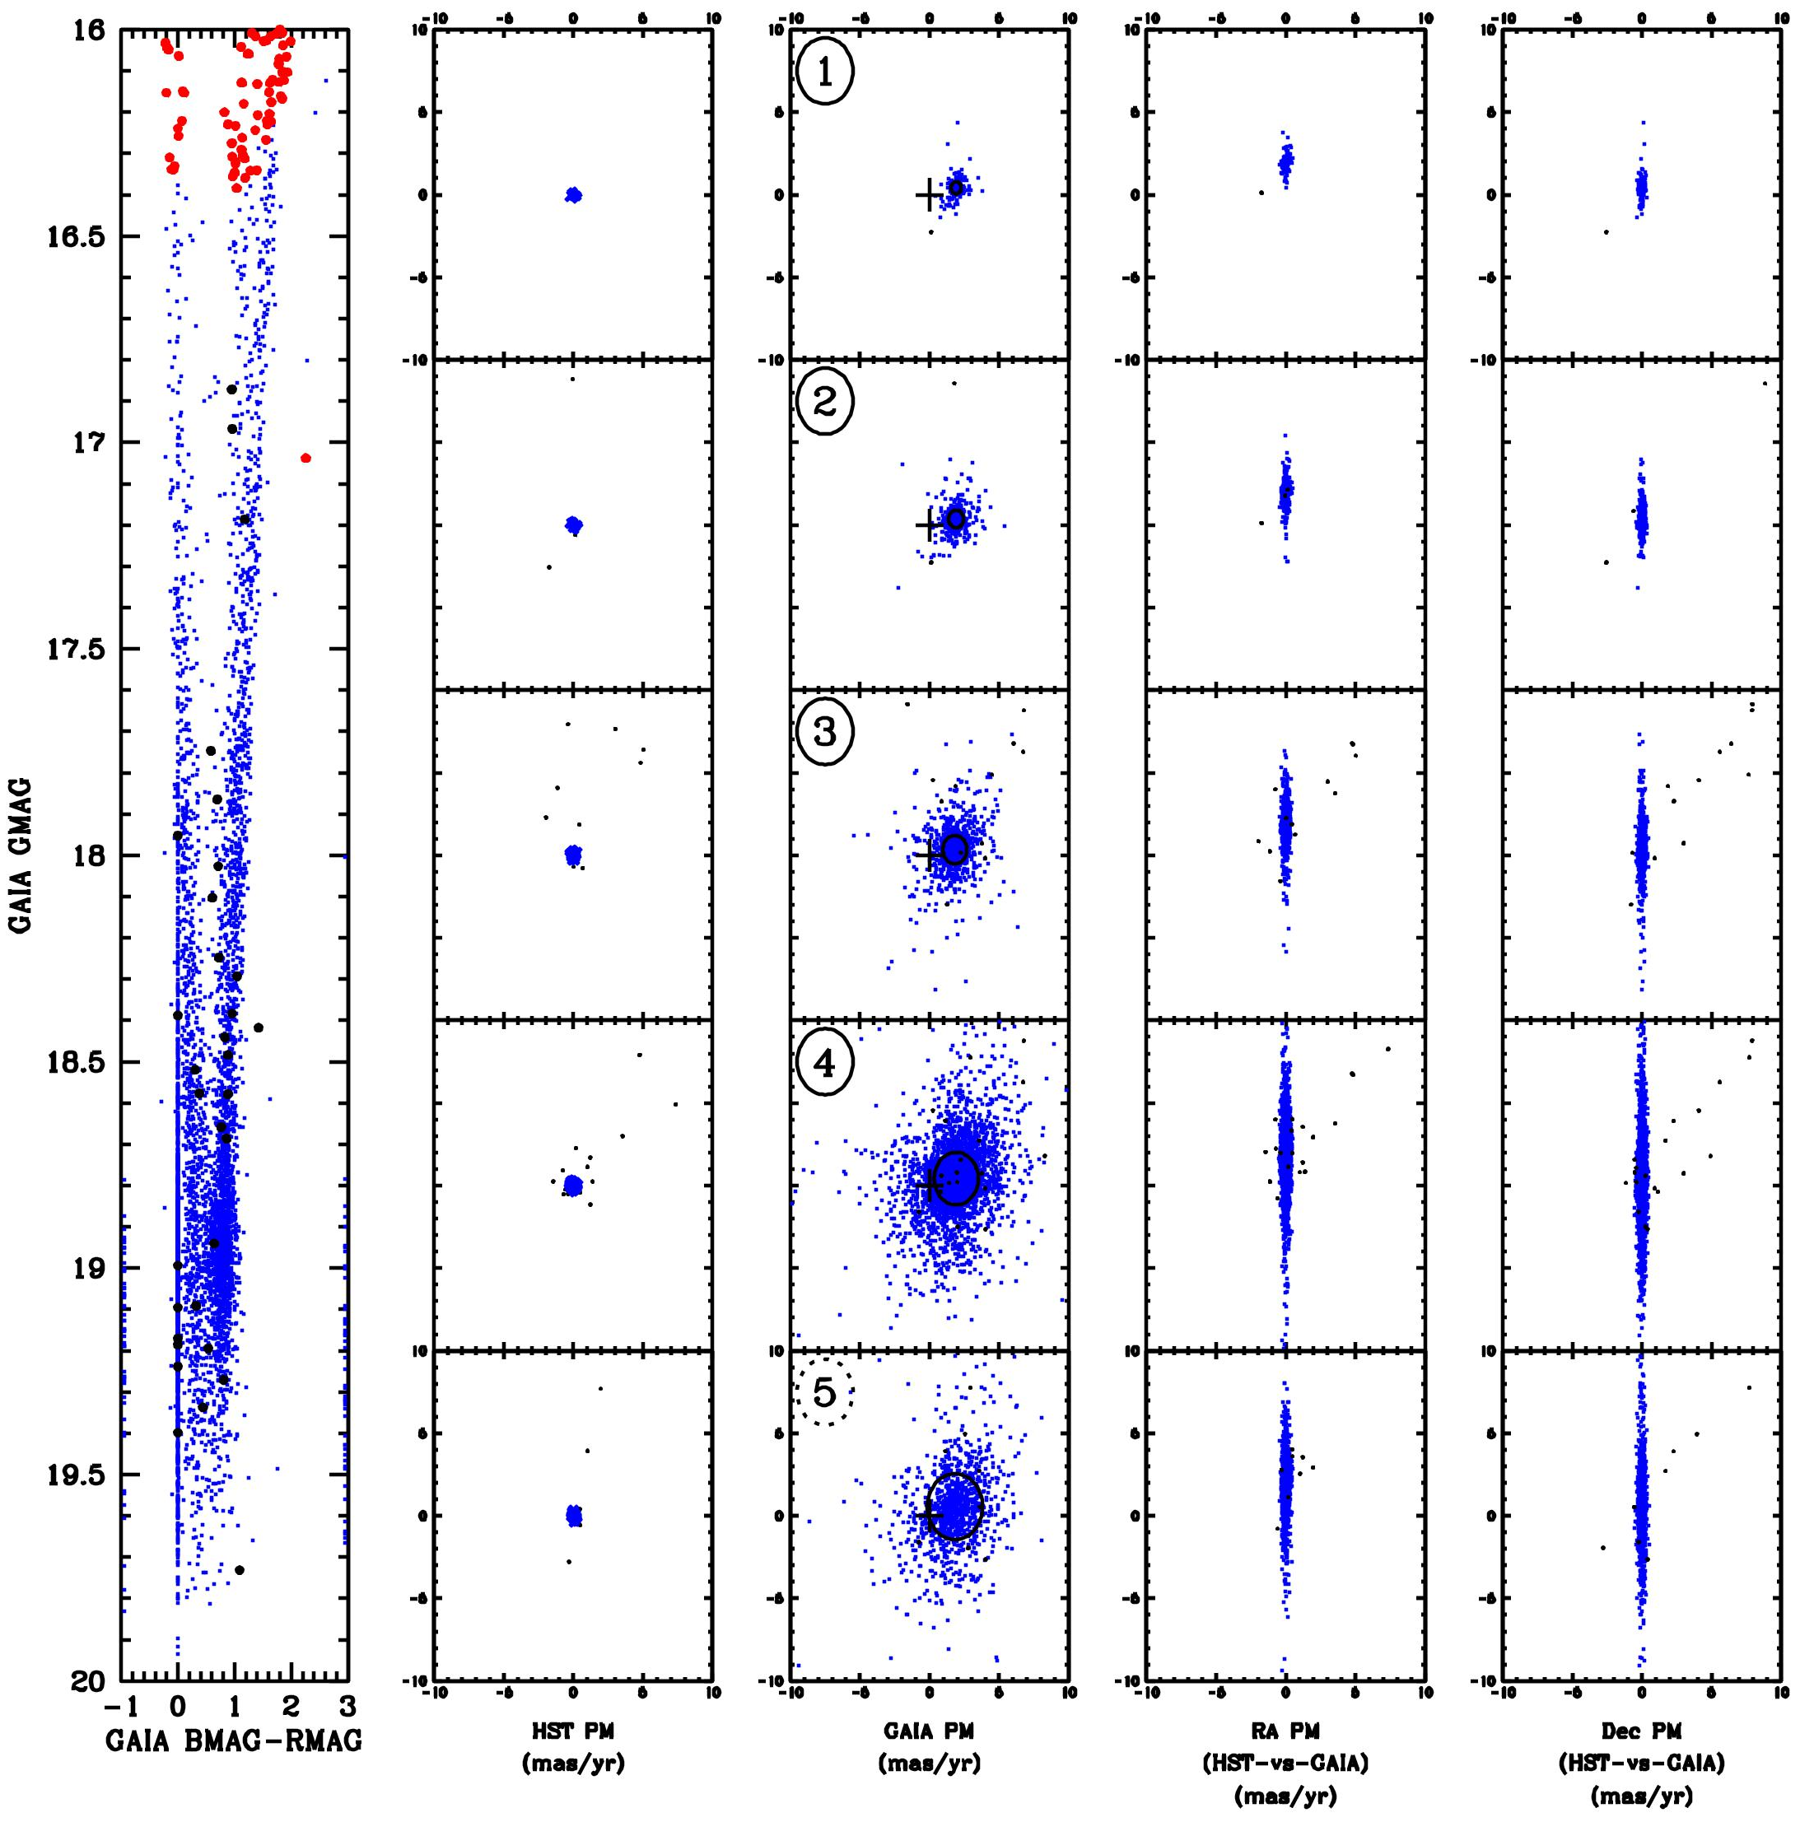
Figure 10: Left: GAIA CMD; the red stars indicate saturation in the short HST exposures. Second panel: HST proper motions in the magnitude intervals corresponding to the adjacent CMD. Stars moving with the LMC (peculiar motion less than 0.5 mas/yr) are shown in blue. Field stars are shown in black. Third panel: GAIA proper motions for the same stars. Note the much larger errors in GAIA, as indicated by the larger scatter about the average motion. In each panel, the black circle is indicative of the median star motion. Last two columns: comparison of the RA and Dec proper motions as measured by HST and GAIA. The 1:1 trend can be seen in the high-motion stars.
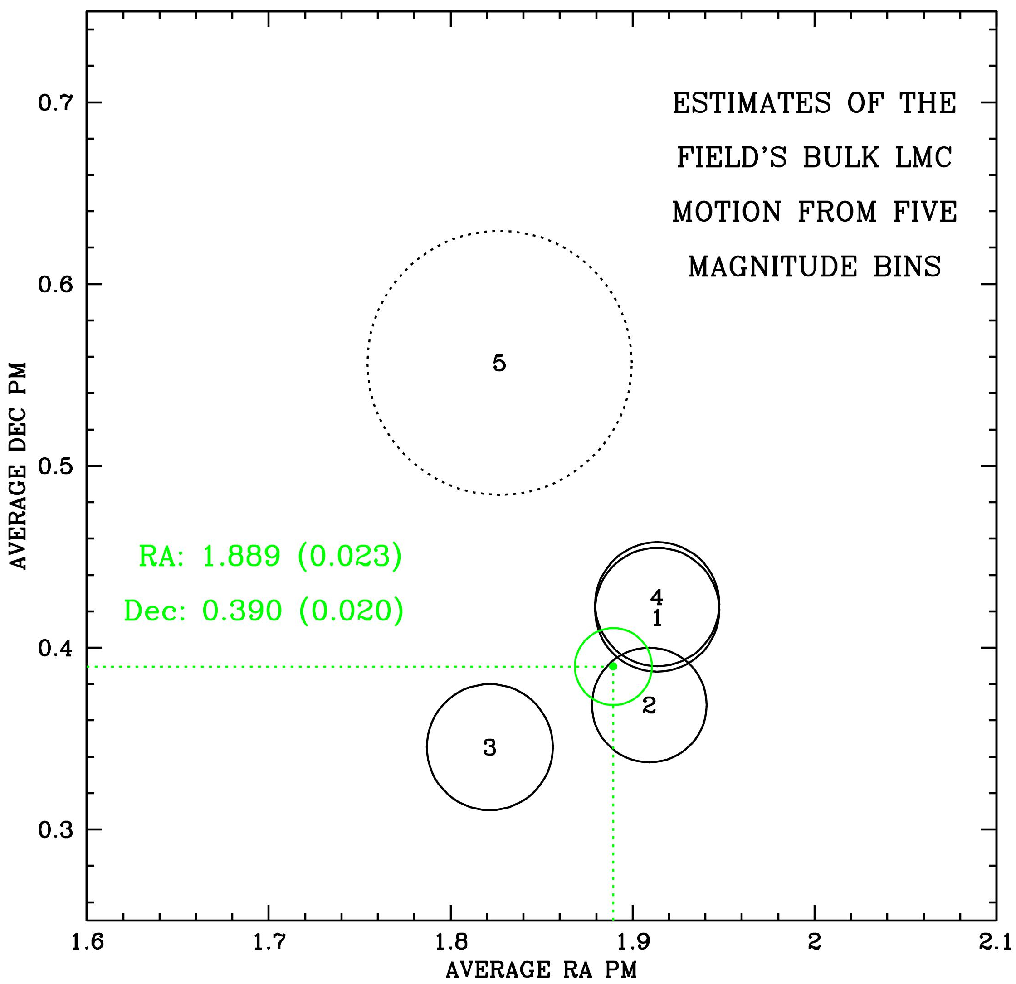
Figure 11: The average bulk motion for the LMC as measured by GAIA for each of the five bins in GAIA G magnitude from Figure 8. The circles indicate the median residual divided by the square root of the number of stars in the bin. Bins 1 through 4 have similar precisions. The 5th bin, containing the faintest and least precise GAIA stars, has very large errors and was not included in the average. The green circle shows the average of the four used bins, with the average and error-in-the-average as shown.

6.2 Step#3: The bulk motion of the LMC in the field.
Figure 11 shows the bulk-motion estimates that were determined from the five individual panels in the third column of Figure 10. It is clear that the estimate from the bottom panel (#5, in red, which spans GAIA G magnitude from 19.2 to 20.0) has larger errors and is only marginally consistent (at the 2-sigma level) with the others. Since its stars are near GAIA’s faint limit, we reject this measurement in our determination of the average. The other four bins (shown in black) have similar net errors-in-the-mean. We determined an average PM and estimated the error from the residuals. We find that the LMC’s bulk motion in this field is μ_{RA} = +1.89 mas/yr and μ_{Dec} = +0.38 mas/yr (in GAIA’s absolute frame), with an error of about 0.02 mas/yr in each coordinate (as determined by the agreement among the four estimates).
Since it is well known that the LMC rotates (van der Marel and Sahlmann 2016), it is worth checking whether we need to include rotation, in addition to bulk motion, in order to properly characterize the absolute motions over the field. In Figure 12 we divided the well measured GAIA stars into five regions: the central region and N, S, E, and W regions. We determined a robust average of the motion in the central region and compared the average motions in the flanking regions to this. We found that none of the regions shows more than a 5% difference in bulk motion, and there were no clear trends. Therefore, we feel secure representing the LMC star motions with only a bulk component.
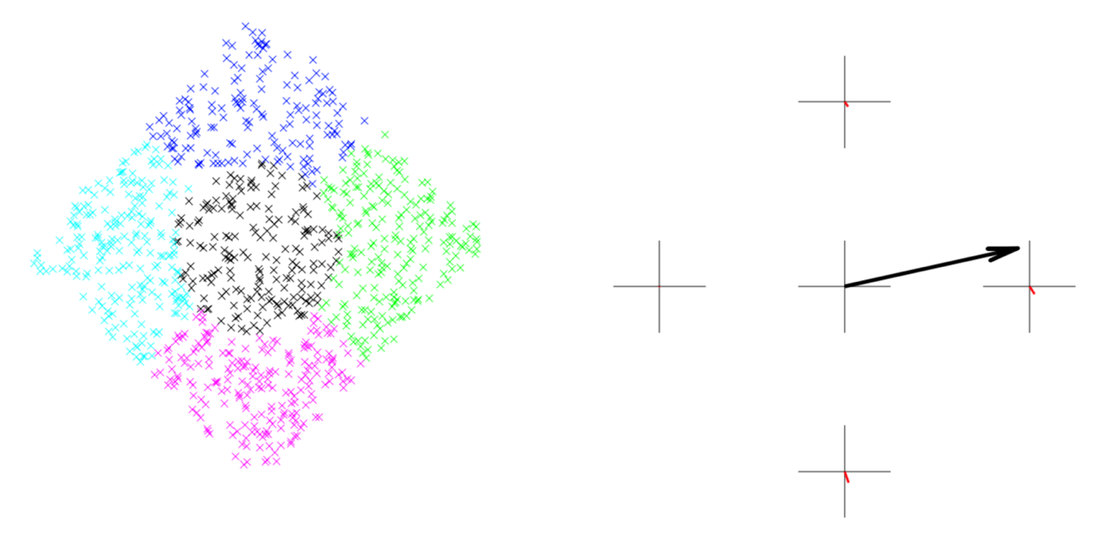
Figure 12: (Left) The stars in our field used to evaluate the rotation component of the motion. (Right) The central arrow shows the bulk motion and the red lines in the four outer quadrants show the residual of the motions in that quadrant relative to the bulk. The residuals are all ~5% or less and show no trends.

6.3 Step#4: Making GAIA-based reference frames for HST
As mentioned above, if we were to simply take the measured GAIA motion for each individual star and project it backwards to 2006 and forward to 2017, the PM errors for each star would introduce large errors in the positions. This was seen in Figure 7 for the 2017 epoch; this would be all the more the case for the 2006 epoch.
However, now that we have an estimate of the LMC’s bulk motion, we can use the GAIA DR2 2015.50 positions to generate an astrometrically accurate reference frame for the LMC stars for two HST epochs. To do this, we took GAIA’s 2015.50 positions and projected them forward rigidly with the LMC bulk motion by 1.86 years to get an astrometrically accurate frame that represents the 2017.38 epoch and projected them backward by 9.12 years to get the 2006.39 frame. In this projected catalog, we included only the LMC member stars that were flagged as such by HST in the reference list.
The frame we have adopted as the official reference frame has a pixel scale of 50 mas/pixel (i.e., that of ACS/WFC), oriented with North up. The center of the frame, pixel [5000,5000], has RA = 80.5° and Dec = –69.5° (53:22:00, –69:30:00). It is easier to work in a pixel-like space rather than RA/Dec directly since residuals in the pixel space can be immediately understood in terms of measurement errors and other detector trends. We can also make optimized image stacks in such frames.

Transforming HST into the Absolute Frame
We described above how the frame was specified, but in practice our actual “handle” on a frame comes from the positions of stars that we have in that frame. To this end, we now have absolute positions with GAIA-DR2-level positional errors for the LMC stars at epoch 2006.39 and at epoch 2017.38. We can use these absolute positions to transform the HST positions into the absolute celestial frame at these two epochs. In the flow chart in Figure 9, we are following the red arrows on the right from Step#4 to Step#5.
Since the LMC stars are moving in-bulk with respect to the absolute celestial frame, their positions in the 2006 frame are offset by about 0.05 pixel with respect to their positions in the 2017 frame. If we use the appropriate-epoch reference frame when we transform the HST positions, then the motion of the LMC (as well as that of the field stars) should be properly reflected in the absolute frame, both in terms of their positions and their motions.
In principle, we could forego GAIA and use background galaxies to define the absolute reference frame (or, at least, a zero-motion inertial frame). Unfortunately, on account of the large number of stars in the field and the moderate background, it is not easy at all to identify point-like background galaxies that could be measured well. There are a few well resolved galaxies, but it is hard to measure their positions with any useful precision.

7.1 Step #5: Boot-strapping the GAIA frame to the short exposures
The next step is to transform HST-measured positions into the absolute frame that is appropriate for their epoch of observation using the linear transformations described in §4.2. This procedure is complicated by the fact that most of our HST images were taken with a ~350s exposure time, since those images will be well matched to the depth of the JWST images. But these deep HST exposures have poor overlap with the GAIA catalog. The unsaturated stars in these images are the very faintest stars in the GAIA catalog, and their positions have large measurement errors in GAIA’s DR2.
For this reason, we used the short HST exposures as an intermediary between the GAIA catalog and the deep HST catalog. We took the seven short exposures from each epoch (five at one orientation and two at the orthogonal orientation) and cross-identified the stars with the LMC-selected GAIA catalog for the appropriate epoch. We used the linear transformations to relate the GAIA positions to the distortion- and CTE-corrected positions from each exposure. These transformations gave us an estimate of each HST measurement in the GAIA frame and of each GAIA measurement in the HST frame.
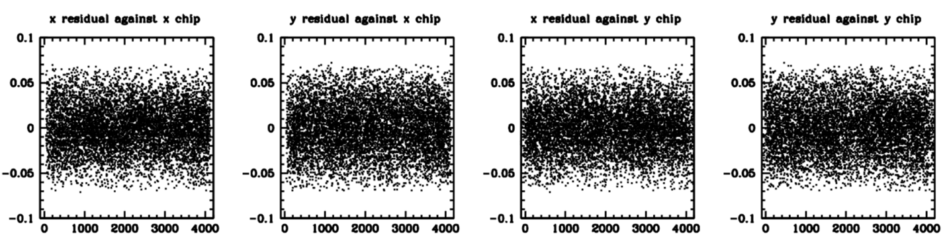
Figure 13: The residuals between where HST observed each star and where the GAIA frame says it should be in that exposure. We plot the residuals in both coordinates against both coordinates. The RMS residual is 0.03 pixel (1.5 mas) in each coordinate.
Figure 13 shows the combined residuals for the seven short exposures of the first epoch. Each point represents a star measured by both HST and GAIA. The residual corresponds to the difference between where HST found the star (in its own frame) and where the linearly transformed GAIA 2006 position says it should be in that HST-image frame (modulo ~7 years of internal motions). We plot these residuals in the HST frame so that any residual trends with detector location can be assessed. There are no significant residuals with chip location, indicating that our net distortion corrections were good. Recall from §4.2 that in the transformations from the individual HST frames into the reference frame were done using a separate transformation for each amplifier, so that any residual parallel or serial CTE might be removed to first order. The typical residual is about 0.03 pixel (1.5 mas) in each coordinate. Some of this residual comes from errors in the GAIA catalog, some from errors in the HST measurements, and some from LMC internal motions. (Recall that the stars have been selected to have LMC-like bulk motions, but there is some internal motion that GAIA could not measure accurately.)
For every measured star in each first-epoch HST image, these transformations give us an estimate of its position in the 2006 GAIA-based reference frame. We would like to combine the positions within each epoch to get an HST-precision position in the reference frame for each star. But since the GAIA list ends at V=20 and even the short HST images have good precision to well below V=21, we need an improved star list if we want to include all the stars that HST can measure well. To this end, we took the list of HST positions from each epoch that had been transformed into the reference frame and created a new catalog of all the stars that were found in at least two thirds of the possible exposures. (There was as significant mosaic to allow more than the nominal 3’x3’ ACS field to be covered; see Figure 1 for the coverage details.)
This gave us a list of about 50,000 stars that were measured well in the short exposures. For each of these stars, we determined an average reference-frame position for the star, along with an estimate of the error in that average position based on the agreement among the position estimates from the contributing exposures.
The same procedure was performed for the second-epoch short exposures. We took the observed positions in each exposure, cross-identified the stars with the 2017 GAIA-based frame, then found average positions in the reference frame for the same 50,000 stars.
These procedures provide a deeper and higher-precision list of positions for stars in the 2006- and 2017-epoch reference frames than the original GAIA-based list had. We will next use these extended and improved catalogs to bootstrap the deep exposures into the absolute frame.

7.2 Step#6: Bootstrapping the deep exposures to the absolute short-exposure frame
Although there are no well-measured GAIA stars that are also measured well in the deep exposures, there is good overlap between the short and deep HST exposures. Stars that are just barely unsaturated in the deep exposures (instrumental magnitude of −13.50, about 250,000 total counts) have an instrumental magnitude of about −11.00 in the short exposures and, thus, about 25,000 total counts. Since stars have S/N > 50 down to an instrumental magnitude of below −9, there are about two magnitudes overlap between the well measured stars in the short and deep exposures. This amounts to about 2500 stars in each exposure that can be used to tie the deep exposures into the short-exposure-extended reference frame.
We used the same procedure above to cross-identify stars in each individual deep exposure with the stars in the short-exposure catalog for the appropriate epoch (see §5.1). We used these stars to define the transformation from each exposure into the reference frame for that epoch (again transforming each amplifier separately). We then transformed the position of each star into the reference frame and collated the observations into a new, deeper catalog, again insisting that a star had to be found in at least 2/3 of the exposures available at its location in the field. Each star in this catalog had up to forty observations. There were over 200,000 stars in this catalog with a pretty even distribution across the covered field. We kept the photometry in instrumental units tied to the plentiful 323s exposures.
Recall that when we ran our finding procedure on each exposure (see §3.1), in order to qualify for the list of stars in each exposure, we required that a star have (1) no brighter neighbors within 5 pixels and (2) a minimum of 500 electrons flux over sky within its inner 2×2 pixels. This resulted in a list of about 75,000 likely relatively isolated sources in each exposure.
Each exposure subtends about 3×3 arcmin² and the entire field about 5×5 arcmin², so it makes sense that there would be about 200,000 stars total. This is not a comprehensive list of stars, but it is a good list of the relatively bright, isolated stars that will be most useful for JWST’s astrometric calibration.
Our photometric procedures measured both the saturated and unsaturated stars. The photometry of the saturated stars is quite good when we add up the spilled flux using the method of Gilliland (2004), but the astrometry is only good to about ±1 pixel. For this reason, the saturated stars in the deep exposures are measured better in the short exposures.

7.3 Step#7: Bootstrapping the short exposures into the deep frame.
The deep catalog generated above for each epoch will now be the official reference frame for that epoch. For consistency, we use it to transform each of the short exposures of the epoch into that frame and determined the best short-exposure-based position for each star in each exposure where it could be found. This procedure also enabled us to zero-point the photometry of the short-exposure catalogs to be consistent with the instrumental system of the deep exposures.

7.4 Final catalog for each epoch in the absolute frame.
We now have a deep- and a short-exposure estimate for the position and flux of each star in the absolute frame of each epoch. In addition to the position, we also have an estimate of the quality of each measurement based on the agreement of the multiple independent observations that were combined to determine the average position in that epoch.
The final catalog should contain the best possible position. If the star was unsaturated in the deep exposures, then we adopt that position and flux as the best position/flux. If it was saturated in the deep exposures but is unsaturated in the short exposures, then we adopt the unsaturated short exposure’s measurements as the best value. If it is too bright to be unsaturated in the short exposures, then we adopt the saturated value from the short exposures. Finally, if it is saturated in the deep exposures but not found at all in the short exposures (for instance, at the edges of the field, or in the short-exposure chip gaps), then we adopt the saturated estimate from the deep exposures.
We have about 200,000 stars unsaturated in the deep exposures, 5200 unsaturated only in the short, 100 saturated in the short and about 600 saturated in the deep. It may seem odd that we find more that are best-measured saturated in the deep than are found saturated in the short, but this stems from the fact that the short exposures don’t have the wide-ranging dither pattern that the long ones had, so they don’t cover as much of the field. At the edges of the field, we have only deep exposures, and their saturation level is fainter than that of the shorts, hence even though the short exposures cover more than half the field, there are many more stars only found saturated in the deeps, thanks to the increasing luminosity function.
Finally, we insist that every star in the catalog be found in both epochs, so that we can determine a PM estimate for it. There are certainly some stars that—for whatever reason—did not make it into one catalog or another (perhaps their motion moves them too close to a brighter star), but our focus for this high-precision astrometric catalog is quality over completeness. In Section 10, we will supplement this astrometry focused catalog with fainter, more crowded stars.

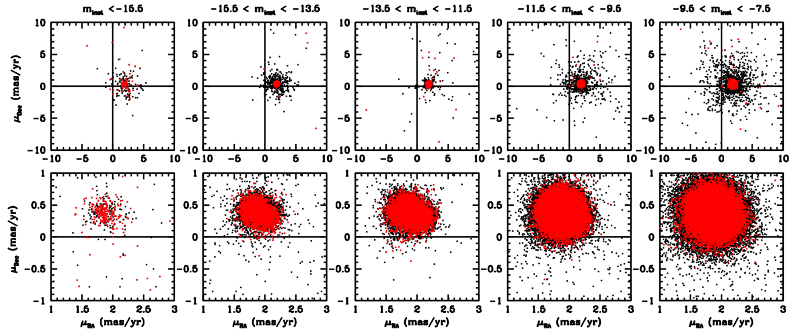
Figure 14: The distribution of observed e2-e1 proper motions for several magnitude bins. The bottom row of plots shows a close-up of the top row. The leftmost two bins (those with stars brighter than –13.5) contain stars that were found only in the short exposures. The entire dataset is shown in black points; the red points over-plotted are those with PM errors smaller than the median for that bin. Note that many of the stars that appear to have high-proper-motions are simply poorly measured (i.e., they are coded black).

Step#9: Determining Proper Motions
The first epoch of HST data was taken in 2006.39 and the second in 2017.38. The time baseline is therefore 10.99 years. Proper motions in mas/yr can be determined trivially by taking the displacement between the two positions in the absolute reference frame and dividing by 10.99 years and multiplying by 50 mas/pixel. For reference, our single-exposure measurement precision is about 0.01 pixel. A star with a proper motion of 0.01 pixel over the 11-year baseline would have a motion of about 50 μas/yr., which corresponds to about 5 km/s at the LMC distance. If we have several observations at each epoch, then this 5-km/s motion can be measured at 2-3 sigma.
Figure 14 shows the distribution of proper motions for various magnitude bins. The panels in the top row show the wide view. Note the displacement of the main population from zero. Normally, HST proper motions have zero net motion by construction (since the transformations are defined by the stars in the two images). However, thanks to our careful construction of epoch-specific reference frames, we have managed to include the bulk motion in the catalog. The panels in the bottom row show a close-up around the main population.

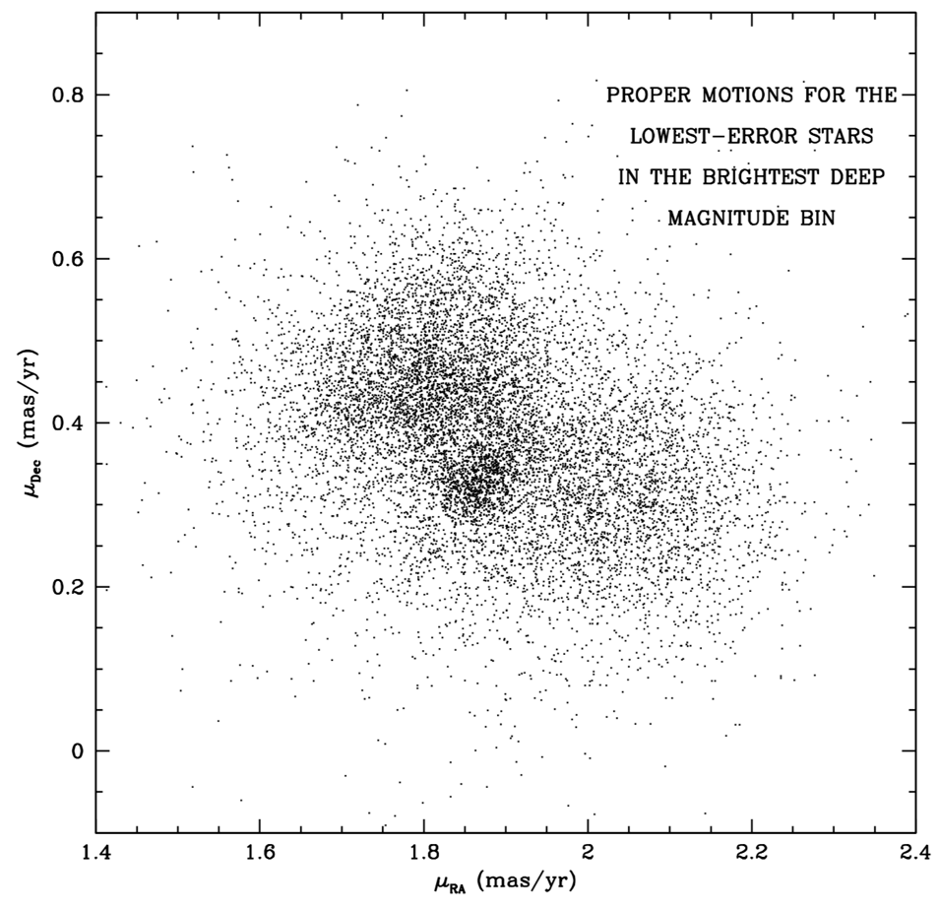
Figure 15: Close-up of the internal motions in the brightest deep magnitude bin (from −13.5 down to −11.5, from the middle panel of Figure11).
The three left-most panels show a clear elongation in roughly the +35° direction. We take a closer look at this distribution in Figure 15, taken from the middle column of panels in Figure 14, where we have the largest number of high-precision stars (these are the brightest unsaturated stars in the deep exposures). It is clear that the LMC stars have a complicated distribution of internal motions. There appear to be three populations. Broad groups in the upper right and lower left, and a relatively tight group in the lower left.
We do not have much GAIA color information for these stars. This bin is almost entirely below GAIA’s faint limit. We do have some F160W exposures taken of the central portion of this field for WFC3 calibration, so it is possible to examine where the different PM populations lie in CMD space.
Figure 16 shows that the stars in the upper left and lower right are made of both old and young stars, while the tight clump in the middle appears to be young stars. We appear to be seeing the cold young disk and the asymmetric-drift motion of the older stars.
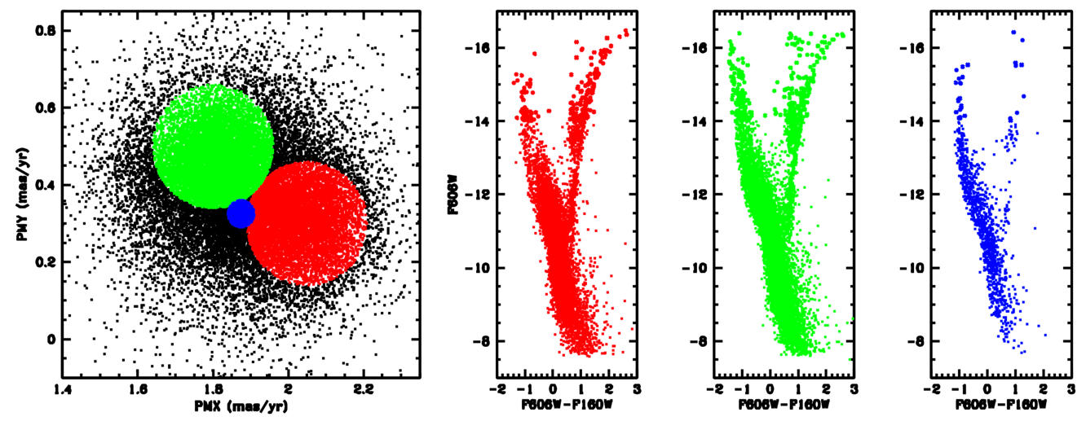
Figure 16: The left panel shows the vector-point diagram from Figure 14. The next panel to the right identifies regions of interest in the vector-point diagram, namely the tight clump in blue and the red and green lobes. The plots on the right show where in the CMDs these stars come from. The red and green stars are similar, but the blue stars appear to be almost all young.

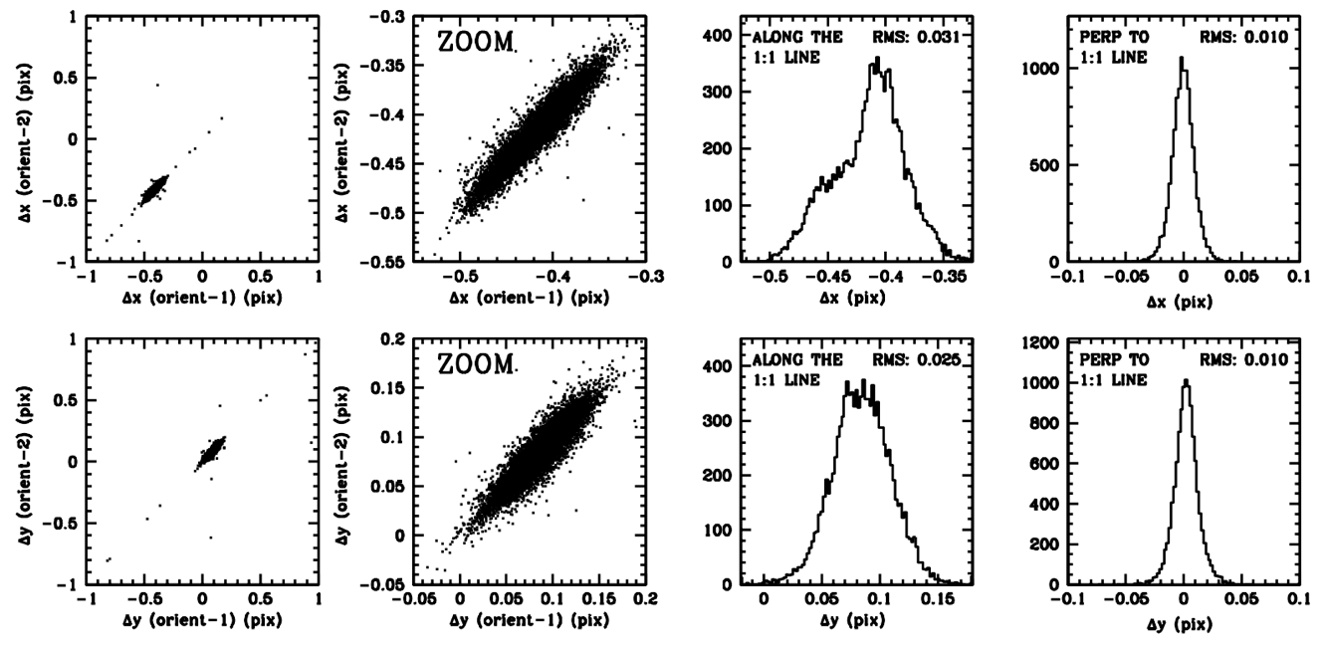
Figure 17: The left panels show the correlation between the motions measured at the first and second orientations, with the x coordinate shown in the top panels and the y coordinate in the bottom panels. These are the brightest unsaturated stars in the deep exposures, the stars for which our motions should be the most accurate. We additionally selected stars that had reasonably accurate positions in both orientations of both epochs. The second column shows a close up around the main distribution. The third column shows a histogram along the 1:1 line. This is indicative of the actual star motions. The final column shows the distribution perpendicular to the 1:1 line. This is indicative of the errors (the difference between the independent measurements from the orthogonal orientations).

8.1 Validating the proper motions
The catalogs we constructed above contain estimates of the error in the position for each star at each epoch based on the scatter of the estimates from the individual exposures at the two epochs. An independent way to validate these errors is to divide the two epochs into two independent observations, those at one orientation and those at the 90°-flipped orientation.
Figure 17 provides this validation. The left panels show the wide view. The stars that lie along the 1:1 line have the same motion measured in the first epoch and the second epoch. Stars that fall off this line have inconsistently measured motions. There are a few field stars that lie on the 1:1 line away from the main distribution, but most stars have small motions relative to the LMC bulk motion.
The next panel shows a close up. The dispersion along the 1:1 line indicates real displacement differences among the stars that are measured to be the same in both halves of the dataset. The dispersion perpendicular to this indicates disagreement between the two measurements and is indicative of our measurement errors.
The histograms in the next two columns show that the dispersion along the motion direction is about 3 times the dispersion along the error direction. The actual motions come from averaging together the independent measurements, thus the error in the average motion is about half the dispersion of the differences. Including these corrections, the typical error in measuring the internal motion for LMC stars is about 15% of the typical motion itself.

8.2 Final comparison with GAIA
Since our procedure has involved multiple steps of boot-strapping, it is worth making sure that our final frame is consistent with the GAIA frame we started with. We compared the final catalog against the original GAIA catalog and get the results shown in Figure 18.

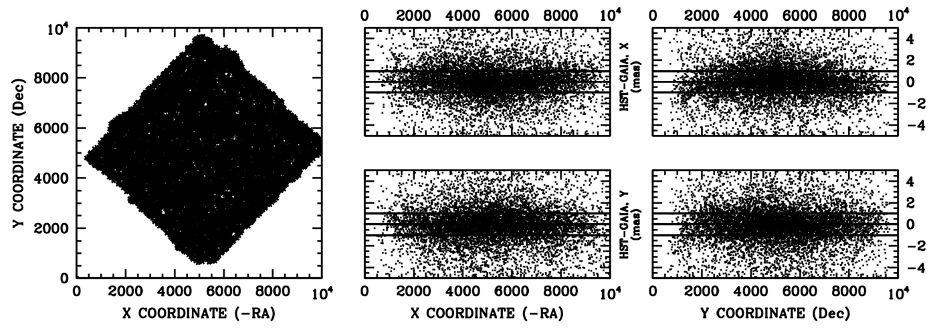
Figure 18: (Left) The overlap between HST and GAIA. The panels on the right show the x (top) and y (bottom) residuals between the HST catalog constructed for 2015.5 and GAIA as a function of x-coordinate (proxy for –RA) and y-coordinate (proxy for Dec). The solid lines on the residual plots correspond to 1 mas.

The field is shown on the left, and the x and y residuals plotted against x and y in the set of panels to the right. For the most part, there are no significant trends, and all the systematic residuals are well below 1 mas. The very left corner of the field does appear to show a very small trend with x (in the upper right panel), but the paucity of stars in this corner makes it hard to be sure that this is significant.

The Well-Measured Isolated-Star Catalog
The above procedure creates one HST-based catalog for epoch 2006.39 and another for epoch 2017.38. The final isolated-star catalog contains the positions of the stars at the GAIA DR2 epoch (2015.5), which we determined by taking x_{2015.5} = 0.1694⋅x_{2006.39} + 0.8306⋅x_{2017.38}, with a similar equation for y_{2015.5}. We also convert these reference-frame positions back into RA and Dec. The final catalog also contains the HST-measured proper motion for each star, along with the error as computed above. For convenience, we also report the measured 2006.39- and 2017.38-epoch positions along with the F160W photometry for the stars that were found in the WFC3/IR exposures of GO-11145 (PI-Dressel).
The catalog and all the supporting files described here can (for now) be found on the following website:
http://www.stsci.edu/~jayander/JWST_CALFIELD2020

The main catalog is a simple text file named master_output.xymvrdeepmeehuGAIA, and it has the following columns:
- X_{2015.5} : reference-frame position
- Y_{2015.5} : reference-frame position
- M_{HST} : instrumental HST F606W magnitude)
- V_{HST} : calibrated VEGAMAG HST F606W photometry)
- RA_{2015.5} : Right Ascension (degrees)
- Dec_{2015.5} : Declination (degrees)
- σ_{RA} : error in RA (mas)
- σ_{Dec} : error in RA (mas)
- μ_{RA} : proper motion in RA (mas/yr)
- μ_{Dec} : proper motion in Dec (mas/yr)
- σ_{μRA} : error in RA proper motion (mas/yr)
- σ_{μDec} : error in Dec proper motion (mas/yr)
- H_{HST} : for the stars found in the WFC3IR exposures, the instrumental magnitude
- FLAG : whether this star was considered “good” in GAIA (see §4.1 for criteria)
- N_{GAIA} : the star ID number from the GAIA catalog (nothing if not in GAIA catalog)
- RA_{GAIA} : from the GAIA catalog, 2015.5
- DEC_{GAIA} : from the GAIA catalog, 2015.5
- GMAG_{GAIA} : from the GAIA catalog
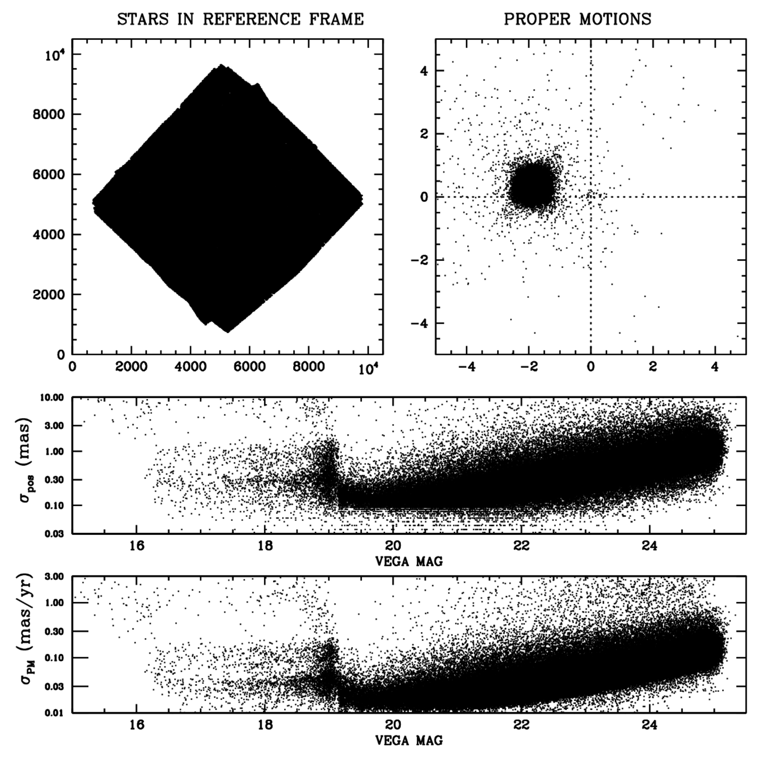
Figure 19: The contents of the final catalog. Upper left: distribution in reference frame. Upper right: vector-point diagram. Lower plots: 2-d positional and 2-d proper-motion errors.
Figure 19 shows the basic contents of the catalog: the distribution of stars in the reference frame, the vector-point diagram, and the errors in position and proper motion. The offset of the LMC from zero motion is clear and consistent with measurements in the literature and the fact that our field is offset somewhat from the center and hence has some transverse motion relative the the LMC center (due to the LMC’s rotation). The upper-right panel shows a few “stars” with near zero absolute proper motion. These correspond to galaxies with bright point-like centers or features.

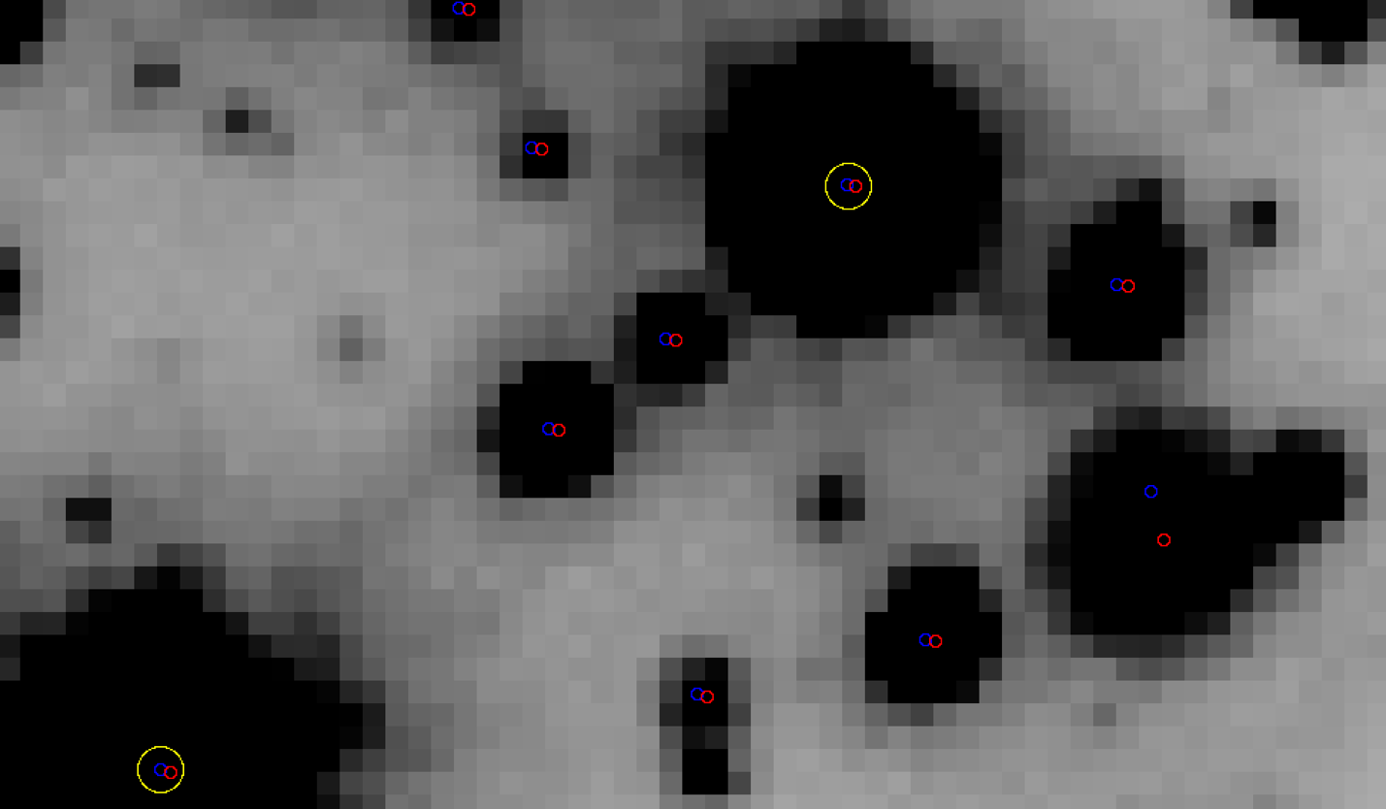
Figure 20: This shows a 60 × 35 pixel (3″×1.5″) region of the 2006 stacked image. The stars circled in yellow were found in GAIA (and are unsaturated in the short exposures). The red points correspond to the 2006 positions for the isolated stars and the blue points correspond to the 2017 positions. There is a clear field star in the lower right.

We also provide a catalog for each of the two HST epochs separately, which includes the x, y, and instrumental HST magnitude, along with the dispersion of measurements about the mean. This should allow users to evaluate any cross correlations between position and motion. Finally, we include a by-epoch descriptor W (how it was found in that epoch: whether saturated or unsaturated in short or deep exposures).
In addition to the catalogs, we also provide a stack of the field taken at each epoch. It is possible to blink the two images and see the stars moving (and see the few visible galaxies not moving). Figure 20 shows a close-up of a few stars in the stacked image, along with where they were found in the different epochs. The bulk motions can be seen easily; one of the stars is a clear non-member. Note the catalog presented in this section contains only the bright, isolated stars. In the next section, we construct a catalog with a more comprehensive list of stars, but the stars here are the ones that will be used for the high-precision calibration, so they are all that many users of the catalog will need.

Beyond the Bright, Isolated Catalog
At this point, the high-precision astrometric catalog is complete. We have positions and F606W fluxes for all the stars along with proper motions that should allow us to project their absolute astrometric coordinates into the near future with reasonable accuracy.
There are plenty of high S/N stars in this list, so it shouldn’t be necessary to identify additional sources that might help with the calibration. Nevertheless, several of the JWST instrument teams would like to simulate realistic JWST observations of the catalog, so that they can run their analysis algorithms on them to ensure that the calibrations can be done the moment JWST starts its commissioning and calibration. In order to do a proper simulation, the F606W catalog needs to be filled out in JWST-band filters and we need to determine how many faint stars may be present that could cause crowding issues for JWST.
To this end, it is not critical to have optimal photometry for each star in every band. But it would be useful to the JWST instrument teams to have a representative set of photometry. As such, we will adopt the observed photometry where we have it, and we will fill in the missing photometry using isochrones and empirical color equations. In addition, we will examine the observed luminosity function and compare it to luminosity functions from stellar models in order to infer how many stars there are faintward of the catalogs.

10.1 Supplemental photometry in JWST-relevant bands
There exist some HAWK-I data of this calibration field from Libralato et al (2014) that can be used to provide photometry in J and K_{S} for the brighter stars. Figure 21 shows the HAWK-I field coverage in green compared to the HST catalog we have been working on. The portion of the field that is covered with F160W HST photometry is shown in blue.
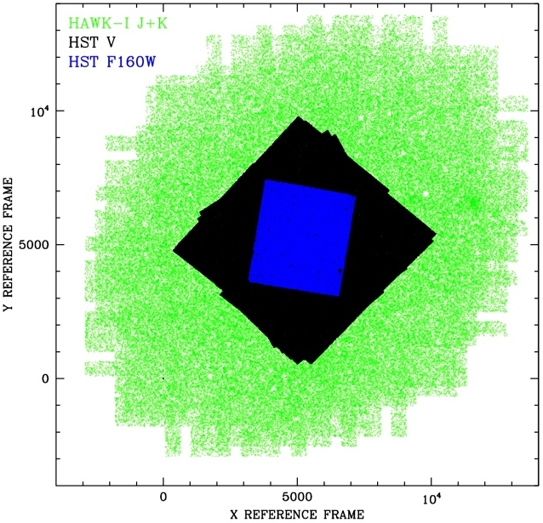  Figure 21: The fields in the reference frame covered by the HAWK-I data (green), the HST ACS/WFC F606W data (black), and the HST WFC3/IR F160W data (blue). | 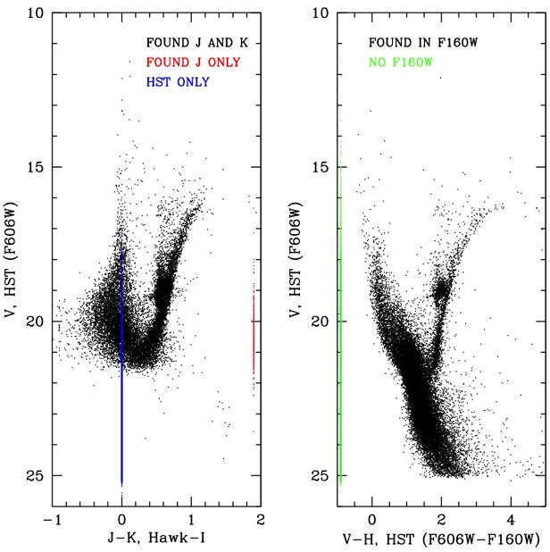  Figure 22: (Left) The HAWK-I J and K data plotted against HST’s F606W photometry. (Right) The F160W WFC3/IR HST data plotted against HST’s F606W photometry.

Figure 22 shows the photometric comparison between the HST stars and the IR photometry. The HAWK-I data (shown on the left) is more complete in J than it is in K; it goes down to V ~ 21, just above the main LMC turnoff. The F160W data from HST goes down to V ~ 25, but there are many stars that could not be found in F160W, partly due to the smaller field coverage, partly due to increased crowding in the IR, where the pixels are 2.5× larger.

10.2 Deeper HST photometry
The star list created in Sections 2 through 9 was is comprised of bright, isolated stars. It is easy to see in the image in Figure 20 that there are many stars in the HST images that did not qualify for this high-precision sample, either because they are too faint or too close to brighter stars. We ran a more comprehensive finding routine that performs an iterative finding and subtraction procedure on all the images of each epoch together in order to find stars that either have nearby neighbors or are too faint to register a significant detection in a single exposure.
This deeper search yielded 256,786 stars, about 1.2× more stars than we had in the original bright, isolated list. This gives us a total of 470,139 stars with HST F606W photometry and positions in the reference frame in 2006 and 2017.

10.3 Extrapolating the star lists
As stars get fainter along the main sequence, they get redder. This means that they fade particularly quickly in the F606W band. JWST will be operating in the infrared, so the stars that are too faint for HST to detect may have appreciable signal in the JWST images.
Instrument teams are interested in knowing how many “unknown” stars there may be, and how much of an issue crowding will be in the commissioning/calibration data. To answer this question, we fit Padova isochrones (from stev.oapd.inaf.it) to the sequences in the F606W and F160W data and this allowed us to infer deep luminosity functions for the stellar populations involved. Figure 23 shows the isochrones we fit to the blue and red populations. They don’t fit perfectly, but there’s no reason to expect the CMDs to be fit by exactly two populations. Furthermore, we are using the isochrones here just as a general guide, so this quality of fit should be adequate.
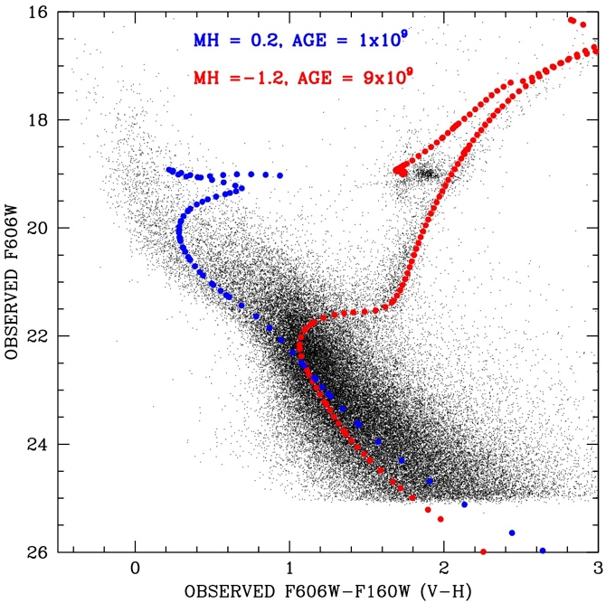
Figure 23: The F606W – F160W -vs- F606W with two Padova isochrones overlaid.

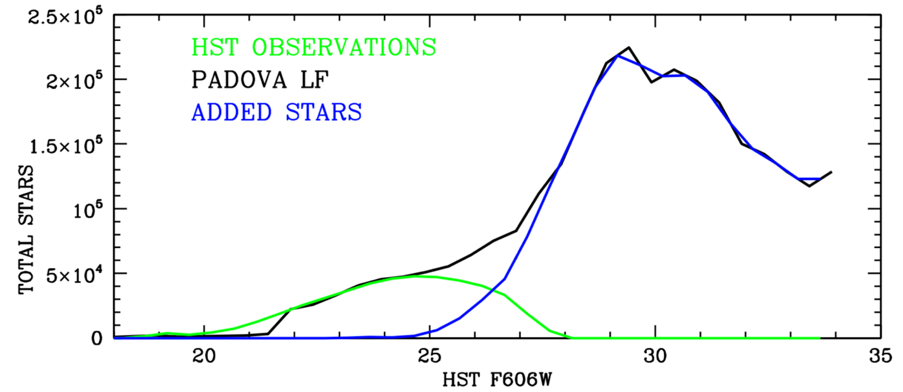
Figure 24: Comparison of the luminosity function for the HST data and the theoretical LF predicted from the Padova models. The difference is the blue stars, and they represent the stars that were likely present but not detected.
We next examined the luminosity function for the old-population Padova isochrone and compared it to the deep F606W HST data. Figure 24 shows the result. The green lines are the HST star lists (both the isolated and the deeper list). The black lines are the Padova LF. Note that the LF doesn’t have as many bright stars as HST observes; this is because of the young population, which is not represented in the model LF for the old population. The blue curve is the difference between the theoretical LF and the observed LF. These are the stars that are likely undetected in the field. We can add them as “artificial stars” to our star lists with random positions in the field so that the instrument teams can evaluate their possible impact on the photometry of the calibration stars. It is clear from Figure 24 that there are about five times more LMC stars that HST didn’t detect than the stars it did detect.

10.4 Multi-band photometry
We have a F606W-band magnitude for every real and artificial star. We have J and K photometry for the bright real stars and F160W (H) photometry for many of the real stars near the center of the field. But many stars do not have observed photometry in V, J, H, and K, and we do not have L or M photometry for any stars.
In an effort to fill-in these missing values, we used color-equation relationships between the observed V, J, H, and K photometry for the brighter stars in the young and old populations to fill in J, H, and K photometry for the stars that were missing it.
In addition to this empirical interpolation, we also used the isochrones to map the J, H, and K colors to the fainter stars below the brightness level where we have any actual observations. In addition, the isochrones allowed us to extend our photometric estimates to the L and M bands as well. These procedures allowed us to come up with a comprehensive set of photometry that the JWST instrument teams can use to get a true sense of what the LMC scene will look like.
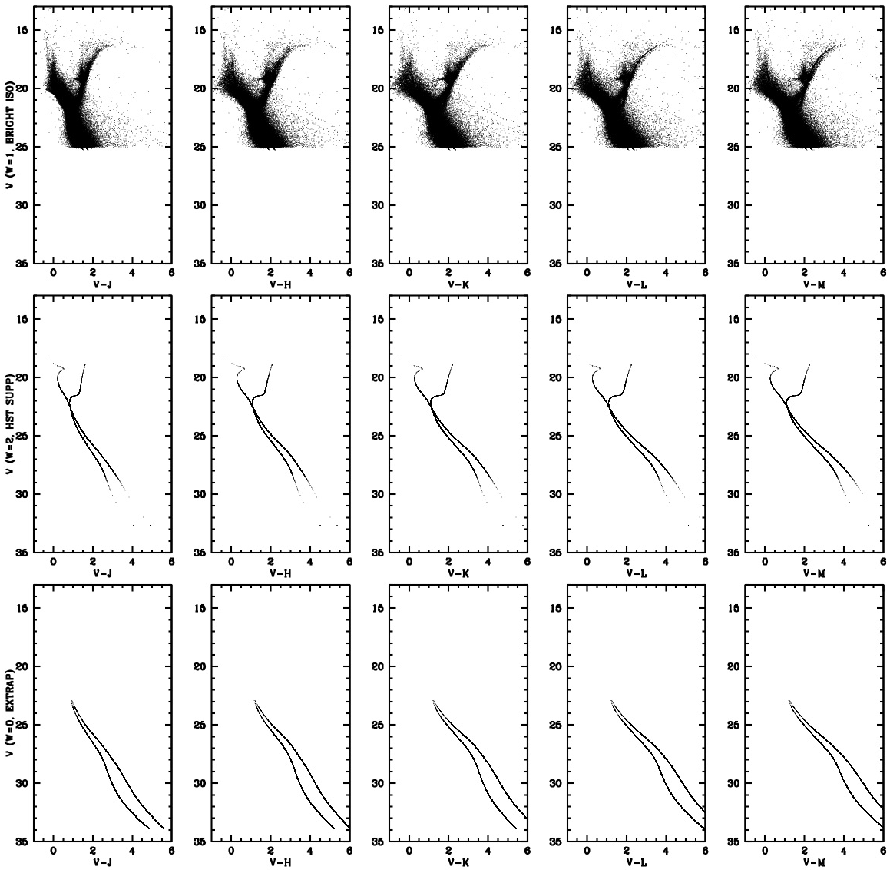
Figure 25: The CMDs for the three different contributing groups to the comprehensive list. The w=1 top group are the isolated stars. We have real photometry in V, J, H, and K, and color-equation transformations to L and M. The w=2 group in the middle are the faint or crowded HST stars; we have only V for these stars, so the other colors come from isochrones. The w=0 group is in the bottom row and corresponds to purely artificial stars designed to fill the luminosity function out to something physical.
10.5 Comprehensive star lists
We provide all this photometry in our “comprehensive” star lists. For each star in this list, we characterize how it was included with the parameter w. There were 213,353 stars in the isolated bright list; they all have w = 1. There were 256,786 stars found in the deeper finding wave, and they are assigned w = 2. Finally, if it is part of our extrapolated effort to estimate the crowding at the faint end, then w = 0. The star is artificial. There were 2,361,982 such stars. The total number of stars in the comprehensive list is 2,832,121. Of course, instrument teams do not need to simulate the entire scene; they can focus on a small region to get a sense of the crowding that they will be dealing with.
For each star, we have either an observation or an estimate of the V, J, H, K, L and M photometry. Figure 25 shows the CMDs in the available bands for the three different groups of stars. Only the top group (w = 1) has real photometry in the IR bands. The other groups of stars have colors that come from isochrone interpolation.
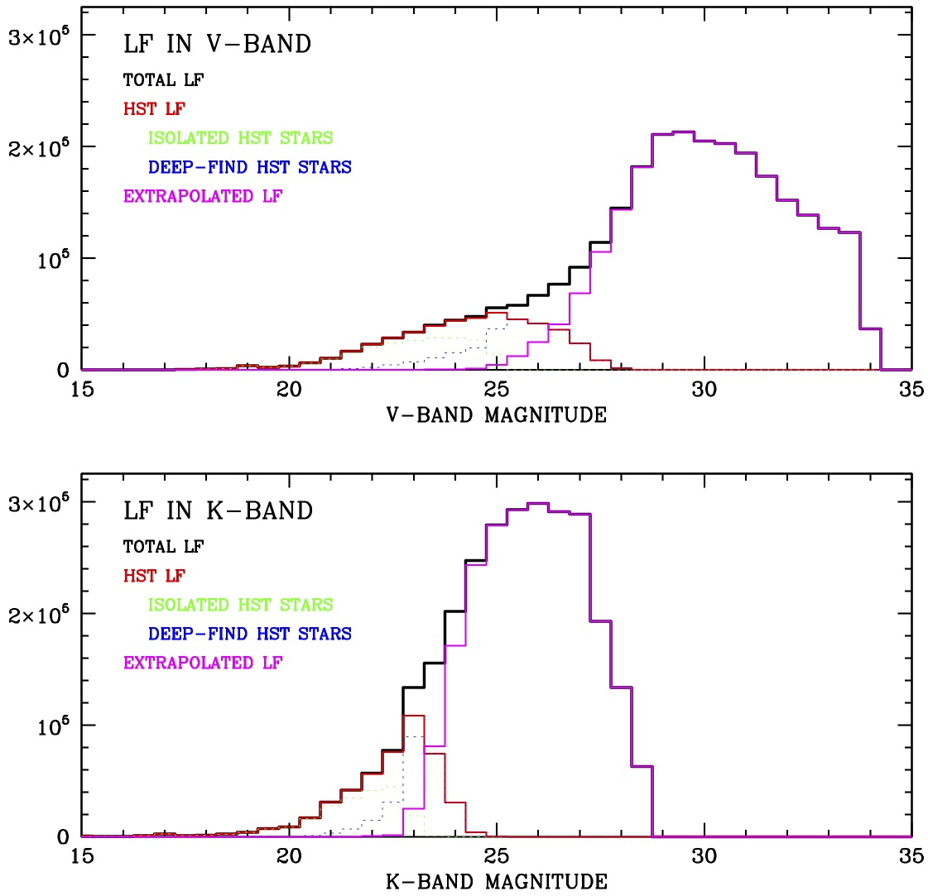
Figure 26: Luminosity function in V and K for the “comprehensive” star list, which contains all the stars that HST found along with some artificial stars to represent those that HST could not find. The LF in K, which will be more typical of JWST observations, is much steeper than that in V.
Figure 26 shows the luminosity function in V and in K for the various subsets of the list. It is clear that the LF in K is much more compact at the faint end. In V, the true LF peak is about 4 magnitudes fainter than the HST-based LF peak, but in K it is only 3 magnitudes fainter. This implies more faint-star crowding in K. The brightest unsaturated stars in the deep images are at V ~ 19 or K ~ 17.5; they should have the best astrometric precision.
The comprehensive catalog is available in the same location as the isolated list presented in Section 9. We provide one file for the 2006 epoch and another for the 2017 epoch:
COMPREHENSIVE_2006p39.XYVHJKLM_OBS_EST_W_RDF
COMPREHENSIVE_2017p38.XYVHJKLM_OBS_EST_W_RDF

For the stars that had actual displacements between the 2006 and 2017 epochs, we used the observed positions at the two epochs. But for the fainter stars, we adopted the displacement from the average LMC bulk motion. Any epoch YR after 2017 can be simulated by taking x_{YR} = x_{2017.38} + (YR-2017.38)× (x_{2017.38} – x_{2006.39}), etc. Recall that stars with w=1 were found in the isolated catalog, and stars with w=2 were found in the more comprehensive search. Stars with w=0 are artificial; they are not really there; they are just representative of the distribution of stars we could not find with HST.
The README.txt file describes the files available at the file-server website referred to in Section 9.

Stacks of the observations at the two different HST epochs:

LMC_JWSTCAL_2006p39.fits
LMC_JWSTCAL_2017p38.fits

Master isolated-star catalog containing positions, PMs, errors, and GAIA:

master_output.xymvrdeepmeehuGAIA

Catalogs from the two different HST epochs. The error in the position at each epoch can be used to determine the covariances between positions and motions:

combine_2006p39.xym
combine_2017p38.xym

Acknowledgements
We would like to thank Kevin Volk for helping to impose important constraints on the extrapolated IR-band photometry in the comprehensive catalog. This helped to ensure that all the colors were physically reasonable.

This analysis has made use of data from the European Space Agency (ESA) mission Gaia (https://www.cosmos.esa.int/gaia), processed by the Gaia Data Processing and Analysis Consortium (DPAC, https://www.cosmos.esa.int/web/gaia/dpac/consortium). Funding for the DPAC has been provided by national institutions, in particular the institutions participating in the Gaia Multilateral Agreement.

References

Anderson, J. 2008, IR Photometry of the JWST Calibration Field, JWST-STScI-001378
Anderson, J. & Bedin, L.R. 2010 PASP 122 1035, An Empirical Pixel-Based Correction for Imperfect CTE in HST’s Advanced Camera for Surveys
Anderson, J. & Diaz, R. 2011, Validation of the Astrometry in the JWST Calibration Field, JWST-STScI-002474
Anderson, J. & Ryon, J. 2018 (ACS ISR)
Anderson, J. hst1pass 2021, (WFC/ISR in prep)
Anderson, J. & King, I. R. 2006, PSFs, Photometry, and Astrometry for the ACS/WFC, ACS/ISR 2006-01
Anderson, J. 2007, Variation of the Distortion Solution of the WFC, ACS/ISR 2007-08
Diaz-Miller, R. I. 2007, Photometric and Astrometric Calibration of the JWST Instrument Complement, ASP Conference Series, 364, 81
Gaia Collaboration et al. (2016): Description of the Gaia mission (spacecraft, instruments, survey and measurement principles, and operations
Gaia Collaboration et al. (2018b): Summary of the contents and survey properties.
Gilliland, R. 2004, ACS CCD Gains, Full Well Depths, and Linearity up to and Beyond Saturation ACS/ISR 04-01
Kallivayalil, 2006 ApJ 638 72
Libralato, M. et al. 2014, A&A 563 80L, Ground-based Astrometry with Wide-Field Imagers. V. Application to Near-Infrared Detectors: HAWK-I @ VLT/ESO
Rhoads, J. E. 2005, HST Observations in Support of JWST Calibration, HST 2005 Calibration Workshop Proceedings, p. 360
Sahlmann, J., 2019, Astrometric catalog for JWST focal plane geometric calibration, Technical Report JWST-STScI-006828 STScI
van der Marel, R. P. & Sahlmann, J. 2016, ApJL 832 23

